**Work In Progress Report**

**CleckShopHub**

**Team Members:**

Abhishek Poudel

Amulya Shrestha

Biliyas Maharjan

Biraj Shrestha

Shashank Shrestha

Soya Shrestha

Sushan Bhandar

Table of Contents

1. Initiation Phase 3

1.1 Project Charter 3

Version Control 4

Project Justification 4

Project Scope 5

Duration 7

Estimated Budget 7

Roles and Responsibilities 8

1.2 Team Contract: 9

A. Team Structure: 10

B. Team Procedures: 11

C. Team Participation: 12

D. Personal Accountability: 13

E. Consequences of breach of contract: 14

1.3 Team Meetings: 16

2. Planning Phase 25

2.1 Belbin Analysis 25

2.2 Skill Audit 28

2.3 Project Management 34

Gantt chart 34

Timeline 34

Calendar 35

Resource Sheet 38

Change working time 39

Communication Tools Used: 40

Discord 40

GitHub 40

3. Execution 41

3.1 Entity Relationship Diagram (ERD) 41

3.2 Extended Entity Relationship Diagram (EERD) 42

3.3 Composite Model 42

3.4 Logical Table 43

3.4 Use Case Diagram 44

3.5 Requirement Catalogue 48

➢ A: Product 48

➢ B: Customer 49

➢ C: Trader 50

➢ D: Management 51

Non-Functional Requirement 51

➢ E: Non-Functional 51

3.7 Logo Design 52

3.8 Wireframes 53

Home Page and Product Search Page 53

Customer Profile and Order History Page 54

Shop page 55

Admin Website Dashboard and Database Dashboard 56

Sign up and login for customer 57

Sign up and login for Traders 58

Admin Login and shop detail during sign up page 59

About Us 60

Contact Us 61

3.9 Product Development 62

Front End Development 62

Homepage: 62

Product Page: 63

User Profile page: 64

Customer Signup Page: 65

Customer Login Page: 65

Backend Development: 66

# 1. Initiation Phase

## 1.1 Project Charter

|  |
| --- |
| Project Title CleckShopHub |

### Version Control

|  |  |  |
| --- | --- | --- |
| Version | Date | Summary of changes |
| 1 | 03/03/24 | Initial version |
|  |  |  |

### Project Justification

|  |
| --- |
| The project aims to develop an e-commerce website platform for independent local businesses located in a vibrant suburb of Cleckhuddersfax. These local businesses have grown and offer local products. As national chains and convenience stores are expanding, the local stores are realizing that they need to adapt different measures to satisfy the needs of the customers.  Traders have thus decided to develop a joint e-commerce website as a solution. The website shows various products that they offer and expands their reach beyond normal business hours. Traders want to provide their customers with a pleasant purchasing experience, with an emphasis on convenience which the website can provide.  The e-commerce website is made specifically to address traders' and customers' needs. Customers may easily browse products by shop or category due to the user-friendly layout. Every retailer keeps a unique range of products, giving clients plenty of options. Every user will find the website easy to navigate as it is accessible on both desktop and mobile devices.  An integrated basket that covers every shop, single payment for all products, and simple buying experience is an essential part of the system. Orders are picked up from a specified location. PayPal payment is one of the payment ways that provides security and flexibility.  For traders, the system gives a user-friendly interface to manipulate their products and shop information. Weekly and monthly financial reviews provide insights into income and overall performance. With separate logins for buyers and traders, and an admin interface for management, the website ensures security and privacy.  All things considered, the e-commerce website is a perfect example of a modern and cultural fusion. CleckShopHub are set to fulfill the changing demands of their community while maintaining the integrity of their local shopping by adapting to the present while staying true to their tradition. |

### Project Scope

|  |
| --- |
| S - Specific   * Establish an online marketplace, called Cleckshophub, to let inhabitants of Cleckhuddersfax buy locally produced goods by filling the gap between convenience shop hours and consumer schedules. * Ensure that the website is adaptable to various devices and screen sizes. * Provide options for users to sign up, log in, and add items to their shopping carts. * Include a review and rating system to collect product feedback for quality assurance. * Provide a navigation menu for easy browsing of product categories with searching and sorting options. * Provide necessary content, including product images and descriptions. * Ensure secure transactions via PayPal or Stripe to enable users to make payments.   M - Measurable   * Provide traders with reports to help them track sales and get valuable insights. * Track the number of orders and related payments to evaluate the effectiveness of the platform. * Provide an elaborative dashboard that shows the progress of the entire project.   A - Achievable   * Create search and sort functionalities to improve the user experience. * Implement quality control techniques using client feedback and ratings. * Allow unregistered users to add things to their wish lists while encouraging registration for further advantages.   R - Relevant   * Analyze sales data to inform business growth plans for traders. * Collect client input to find areas for enhancement and improve the user experience. * Present statistically important data in a visual format for rapid examination and decisions.   T – Time Bound   * Project Start Date [03/03/2024] * Project Deadline [25/05/2024] |
| **Customer Interface**   * The Customer Interface caters to a vibrant local market, supporting 5 to 10 traders and delivering a diverse choice of products that are easily discovered using an advanced search and sorting engine. * Comprehensive product pages offer important features such as price, nutritional information, and allergens, allowing shoppers to make informed decisions. * Designed for universal accessibility, the interface is responsive across all devices and browsers, increasing user engagement. * Features consolidated shopping cart and wish list capabilities, improving the shopping experience for both visitors and registered customers, as well as increased security through email verification of account actions. * Emphasizes security and usability with a user-friendly layout and safe user data management, providing a trustworthy and efficient purchasing experience. * Features a system for selecting pickup times, assessing orders before confirmation, as well as email summaries after purchase to confirm specifics and build consumer trust. * Enhances product interaction with a quick-view modal, making browsing and purchasing easier by presenting important information and rapid ordering alternatives.     **Trader Interface**   * Traders may easily manage their profiles and product listings, with a full dashboard providing insights into sales, consumer behavior, and inventory management. * Advanced product management capabilities are included, allowing for easy additions, changes, and removals of products via CRUD (Create, Read, Update, Delete) activities, ensuring that their offers stay current and appealing. * Provides sophisticated order management tools that allow traders to track and fulfill client orders effectively using numerous filtering options, hence increasing operational efficiency and customer satisfaction. * It has a secure login system that ensures important corporate information is kept secret and only available to authorized individuals. * Provides access to analytical tools and reports, offering traders with useful data on sales patterns and performance indicators to help them make smart decisions. * Provides a responsive interface design, allowing traders to manage their operations from any device while maintaining flexibility and continual access to their business. * Gives traders the chance to reply to customer evaluations, encouraging direct connection with the customer base and providing an opportunity to enhance service and product offers based on feedback.   ﻿**Management Interface**   * Provides an administrator-only login site for managing the platform's operations. * Allows for the maintenance and monitoring of trader accounts, ensuring a diversified and high-quality product offering. * Provides access to a set of analytics and reporting tools for analyzing sales success and user interaction. * Quality control and product inspection elements are included to ensure that the platform's criteria are met. * Creates weekly reports on orders and financial activities to ensure smooth operations and payments. * Tracks site usage and visitor statistics, which helps with platform strategic planning and improvement. |

### Duration

|  |
| --- |
| Project Start Date: 03/03/2024  Initiation Date: 05/03/2024 |

### Estimated Budget

|  |  |  |  |  |  |  |  |  |  |  |  |  |  |  |  |  |  |  |  |  |  |  |  |  |  |  |  |  |  |  |  |  |  |  |  |  |  |  |  |  |
| --- | --- | --- | --- | --- | --- | --- | --- | --- | --- | --- | --- | --- | --- | --- | --- | --- | --- | --- | --- | --- | --- | --- | --- | --- | --- | --- | --- | --- | --- | --- | --- | --- | --- | --- | --- | --- | --- | --- | --- | --- |
| |  |  |  |  |  | | --- | --- | --- | --- | --- | | Team Member | Hours per day | Days per week | Total working week | Total working hours | | Abhishek Poudel | 3 | 5 | 10 | 150 | | Amulya Shrestha | 3 | 5 | 10 | 150 | | Biliyas Maharjan | 3 | 5 | 10 | 150 | | Biraj Shrestha | 4 | 5 | 10 | 200 | | Shasank Shrestha | 4 | 5 | 10 | 200 | | Soya Shrestha | 3 | 5 | 10 | 150 | | Sushan Bhandari | 3 | 5 | 10 | 150 |   Total Working Hours: 1150 Hours |

### Roles and Responsibilities

|  |  |
| --- | --- |
| **Name** | **Role** |
| Abhishek Poudel | Primary Role: Plant  Secondary Role: Resource Investigator  Least Likely Role: Shaper |
| Amulya Shrestha | Primary Role: Resource Investigator  Secondary Role: Plant  Least Likely Role: Shaper |
| Biliyas Maharjan | Primary Role: Team Worker  Secondary Role: Implementer  Least Likely Role: Monitor Evaluator |
| Biraj Shrestha | Primary Role: Co-ordinator  Secondary Role: Complete Finisher  Least Likely Role: Plant |
| Shasank Shrestha | Primary Role: Co-ordinator  Secondary Role: Specialist  Least Likely Role: Completer Finisher |
| Soya Shrestha | Primary Role: Team Worker  Secondary Role: Monitor Evaluator  Least Likely Role: Shaper |
| Sushan Bhandari | Primary Role: Implementer  Secondary Role: Resource Investigator  Least Likely Role: Specialist |

## 1.2 Team Contract:

Project Team Name: CleckShopHub

|  | Team Member Name | Email | Phone |
| --- | --- | --- | --- |
| 1 | Abhishek Poudel | pabhishek22@tbc.edu.np | +977 986-1289432 |
| 2 | Amulya Shrestha | samulya22@tbc.edu.np | +977 982-3547342 |
| 3 | Biliyas Maharjan | mbiliyas22@tbc.edu.np | +977 981-3762592 |
| 4 | Biraj Shrestha | sbiraj22@tbc.edu.np | +977 981-3283814 |
| 5 | Shasank Shrestha | sshasank22@tbc.edu.np | +977 974-6312195 |
| 6 | Soya Shrestha | ssoya22@tbc.edu.np | +977 980-3097697 |
| 7 | Sushan Bhandari | bsushan21@tbc.edu.np | +977 986-0672343 |

### A. Team Structure:

1. Leadership structure:

Leadership structure will be shared among Shasank Shrestha and Biraj Shrestha over the weeks.

2. Decision-making policy:

The team utilizes a majority vote system for decision-making, ensuring efficient resolutions based on the preferences of the majority.

3. Who is the team Recorder/Documentation Manager/Maintainer of team activity?

Soya Shrestha and Amulya Shrestha will be responsible for team recording and documentation management.

The Team Leader is responsible for the maintenance of the team activity.

4. Day, time, and place for regular team meetings:

Team meetings are conducted three to four times a week

Physical meetings will be held every Monday and Friday at the British College.

Virtual meetings will be held on Discord from 7 PM - 9 PM on Tuesday, and Wednesday.

Meeting link: <https://discord.gg/3Gpn4CpwKM>

5. Usual method of communication:

Discord will be used as the method of communication.

* + Discord Link: <https://discord.gg/3Gpn4CpwKM>

For sharing files GitHub and Google Drive links will be used.

* + GitHub Link: <https://github.com/shasankStha/Team-Project>
  + Google Drive Link: <https://drive.google.com/drive/folders/1X0D1ELQ_fgjEWwKxM8uP3SUS_HUKISoC?usp=sharing>

### B. Team Procedures:

1. Method for setting and following meeting:

The agenda for the current week is set by the initiating leader with the assistance of the team leader. The team member discusses their concerns with the team leader prior to the meeting and the team leader will make changes accordingly.

Agendas will be created based on the tasks that need to be completed. It will be created by the team leader. If any issue arises, team members are free to suggest additional ideas.

Team members will be notified or reminded by the team leader through various communication channels such as email and Discord. The team leader may send out a meeting agenda in advance with reminders closer to the meeting time.

During team meetings, it is the responsibility of the team leader to ensure that the agenda is being followed, guiding discussions and maintaining focus; in the event of any unresolved agenda items, the team leader will carry forward the discussion to address them in the next meeting.

2. Method of record keeping:

Soya Shrestha and Amulya Shrestha, the record manager will keep the records, and screenshots and share them by uploading them to a shared Google Drive.

Google Docs link (Record):

https://docs.google.com/document/d/1OjctGEgDaFPTNEzMtuWIXCa-c7Y7nx7K_JGp7ctjyB4/edit

After every meeting, the team leader will update Google Docs with a summary of the decisions made and the activities to be done. After the agendas are set, the team leader will inform the team members through mail or discord.

Google docs link(Agendas):  
<https://docs.google.com/document/d/1fHLIlcgnpMio1IOXG5uFKN075HKMHaIqvVH45gxhCL0/edit?addon_store>

3. Procedures in the absence of a team member:

Meetings can proceed if 70% i.e. 5 team members are present, but decisions that everyone needs to agree on will be put on hold until we can all come to an agreement. If a member is unable to attend due to a legitimate reason, they are required to make up for it by presenting the information at the next meeting.

### C. Team Participation:

6. Strategies to ensure cooperation and equal distribution of tasks:

To ensure cooperation and fairness in task distribution, our team adopts several strategies. We prioritize open communication, ensuring everyone's input is valued, and workload is distributed equally to all team members. Punctuality is emphasized for meetings, with exceptions made in emergencies. We also rotate responsibilities to prevent burnout and promote skill development.  
If any of the team members face an issue, others will assist him/her to come up with a solution.

7. Strategies for encouraging/including ideas from all team members:

Encouraging members to share their ideas by explicitly inviting them and ensuring everyone has an equal opportunity to contribute. Creating an environment where team members can freely express their opinions without worrying about criticism or condemnation.

8. Strategies for keeping on task:

Rely on communication tools like Discord and project management platforms such as GitHub to assign tasks and track progress. Conducting regular team meetings to keep everyone updated on the project's status. Establish working schedules with deadlines for each task to ensure accountability and timely completion.

### D. Personal Accountability:

1. Expected individual attendance, punctuality, and participation at all team meetings:

We expect 80% attendance from each individual. Regular attendance is crucial for effective collaboration and communication within the team. If for any reason an individual cannot attend a meeting, they should notify the team in advance, whenever possible.

Everyone is expected to be punctual for all team meetings. Being on time demonstrates respect for colleagues' time and ensures the smooth running of the meeting. A 15-minute grace period is allowed for unforeseen circumstances. However, this grace period should not be abused and should be used sparingly.

Active participation is essential for the success of team meetings. This includes contributing ideas, asking questions, and engaging in discussions relevant to the agenda. Each team member is encouraged to share their insights, experiences, and concerns during meetings to foster a collaborative environment. Constructive feedback and suggestions for improvement are welcomed and encouraged by all team members.

2. Expected level of responsibility for fulfilling team assignments, timelines, and deadlines:

We expect the members of the team to complete the task by the deadline that was set during the team meeting. We anticipate that each team member will take personal responsibility for their assigned responsibilities and give their all to ensure the project's success. If any member has an issue, he/she can contact the team and address their problem.

3. Expected level of communication with other team members:

Clear and consistent communication among team members is essential for success. It involves providing timely updates on task progress, promptly responding to messages, and ensuring everyone understands project goals and expectations. Actively listening to team members, collaborating on solutions, and offering constructive feedback contribute to a productive environment. Prioritizing effective communication enables teams to work harmoniously towards achieving their objectives

4. Expected level of commitment to team decisions and tasks.

Team members are expected to fully commit to decisions made collectively and diligently carry out assigned tasks. This entails supporting team decisions, meeting deadlines, actively contributing, and addressing challenges promptly. By maintaining a high level of commitment and team effectiveness, success can be ensured.

### E. Consequences of breach of contract:

In case of a breach of the Team Contract, the team member involved may be required to report to the project manager to discuss the situation and potential resolutions. We will speak with them personally and provide them with an opportunity to clarify their behavior. The penalty might be anything from a verbal warning, depending on how serious the violation was three times and the final penalty will be removal from the project team. When resolving such matters, we'll uphold fairness and transparency and make sure that everyone in the team is aware of the responsibilities and penalties specified in the contract.

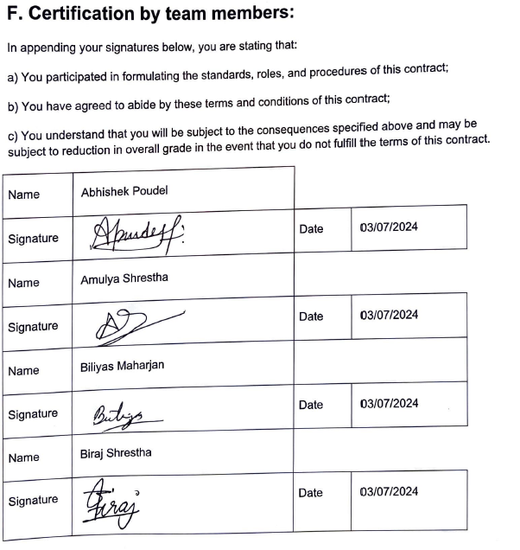

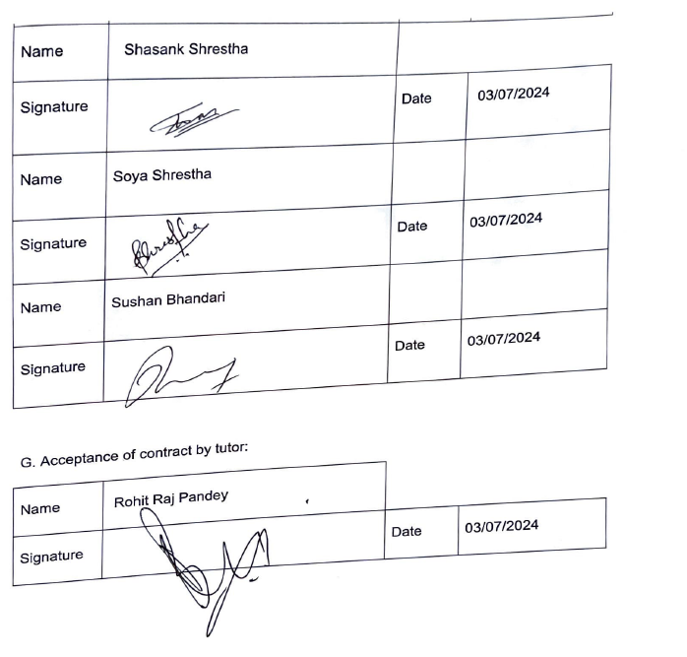

## 1.3 Team Meetings:

**Virtual Meeting:**

**Day 1(03/05/24): (Online)**

**Objectives:**

* Introduction of the team members
* Division of work among the team members.
* Website name decided (i.e. CleckShopHub).

**Day 2 (03/07/24): (Online)**

**Objectives:**

* Began with the contract work and project charter.
* Deliberation and agreement on the project contract.

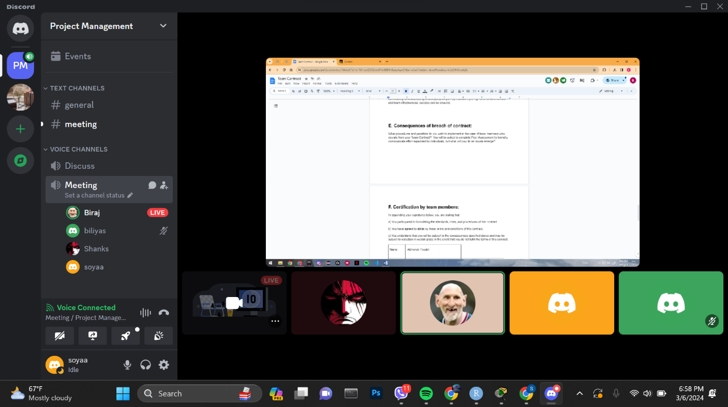

**Day 3 (03/14/24): (Online)**

**Objectives:**

* Reflected upon individual strengths and weaknesses for Skill audit.
* Decided and discussed suitable Belbin roles for each member.

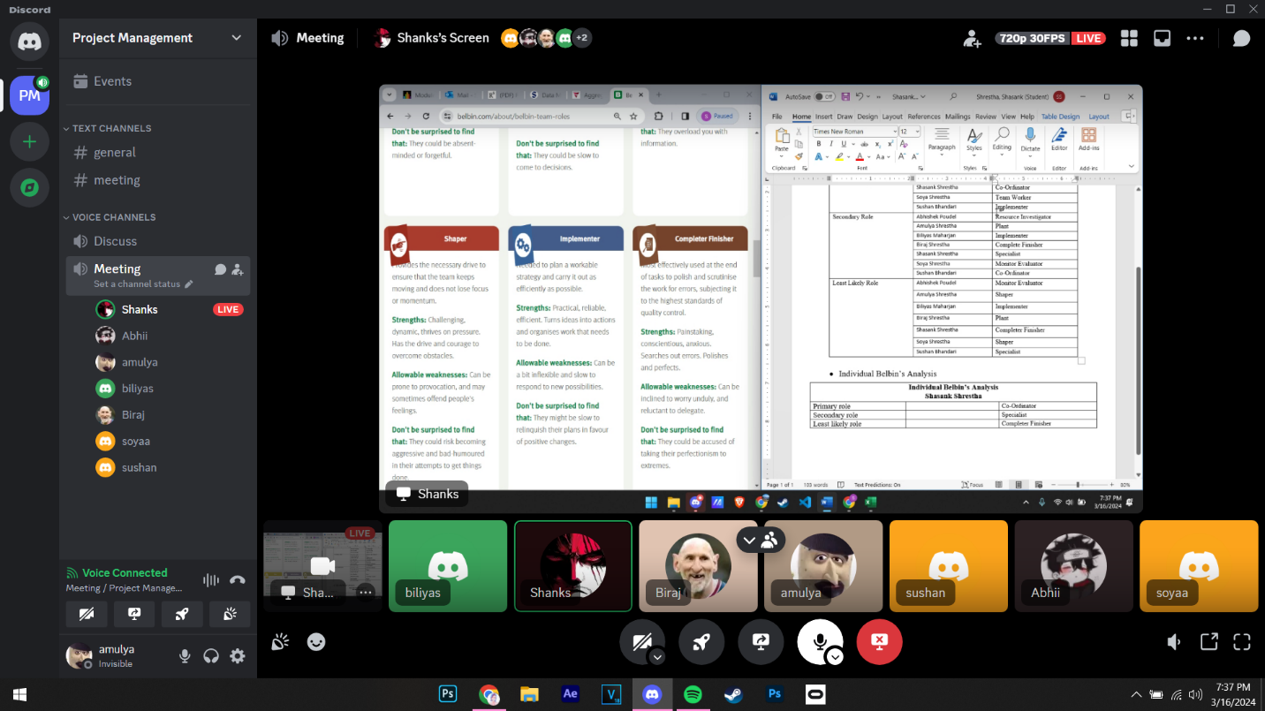

**Day 4(03/15/24): (Online)**

**Objectives:**

* Prepared ERD diagram to design database models used in our site.

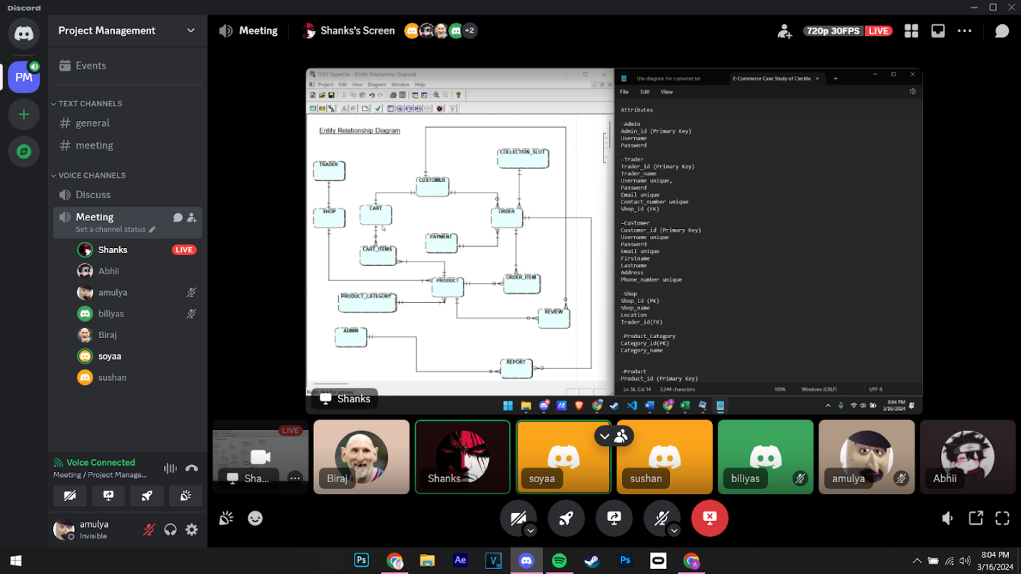

**Day 5(03/18/24): (Physical)**

**Objectives:**

* Began creating wireframes for web pages using Figma.
* Continued working on the ERD.
* Discussion on the logo.
* Started designing a website logo
* Commenced work on the wireframe.

**Day 6(03/19/24): (Physical)**

**Objectives:**

* Made various versions of logo

**Day 7(03/21/24): (Online)**

**Objectives:**

* EERD/ERD/Final Composite & Decomposition ERD/ Logical Table discussion and submission.
* Continued making wireframes.

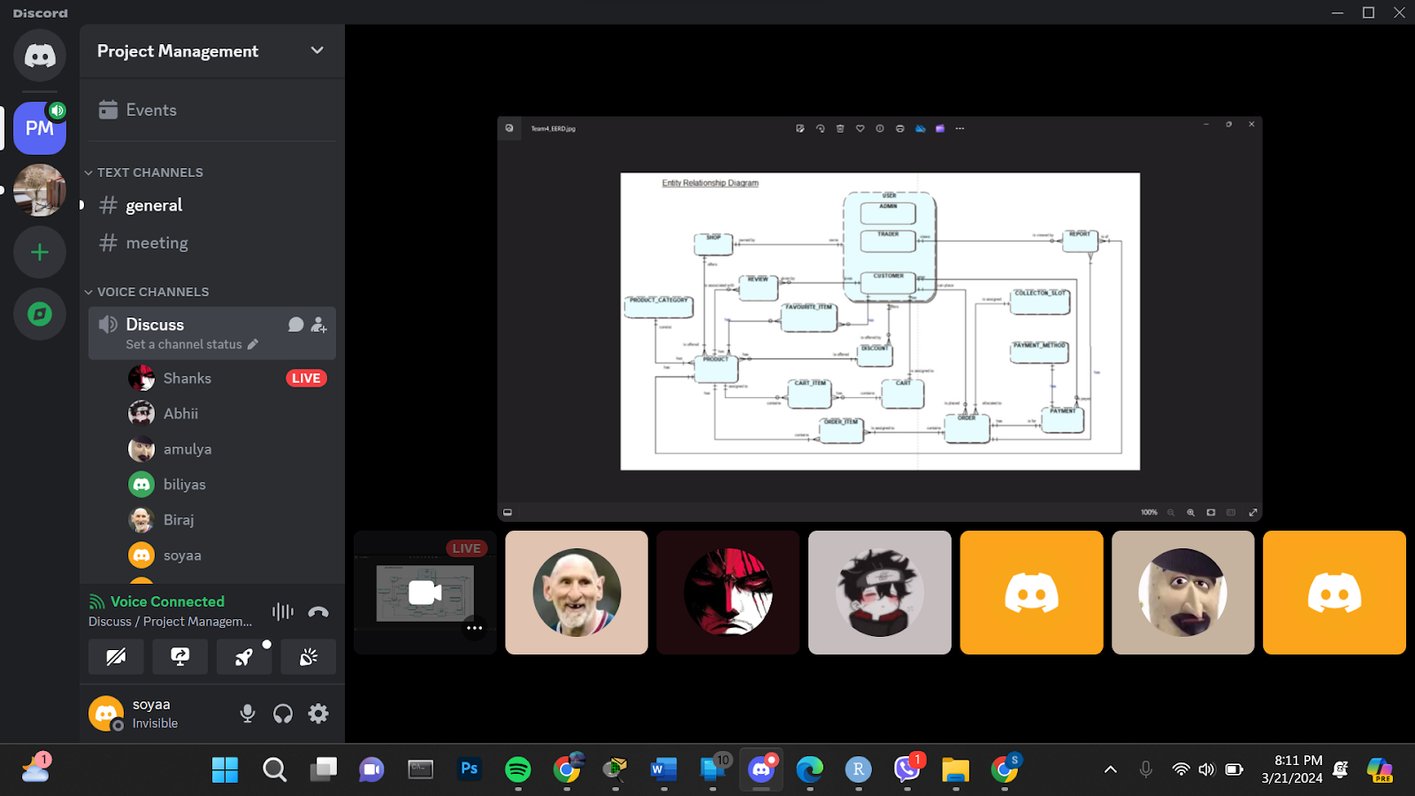

**Day 8(03/22/24):**

**Objectives:**

* Started working on Use Case Diagram
* Continued Wireframe.
* Started working on use case diagram
* Discussion on Functional and Non-Functional Requirements.

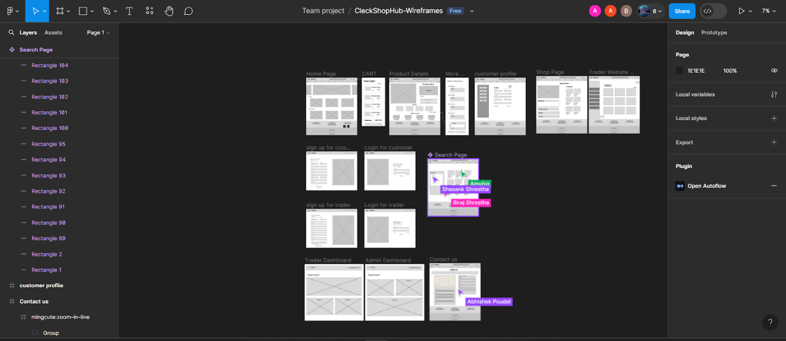

**Day 9(03/25/24):**

**Objectives:**

* Worked on Functional and non-functional requirements

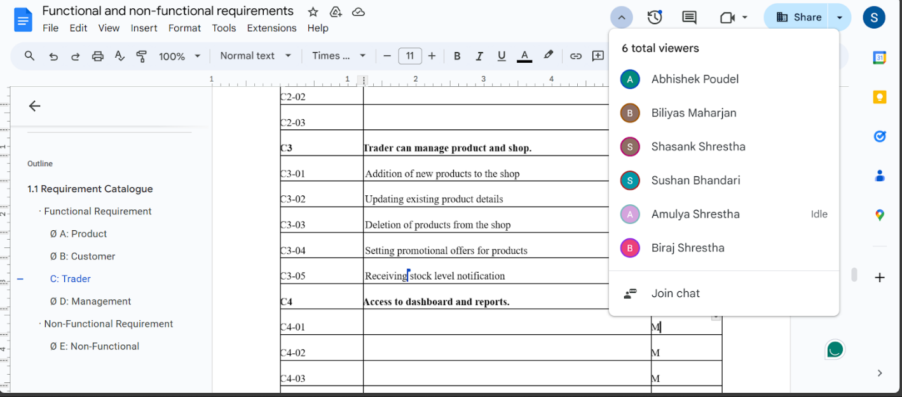

**Day 10(03/26/24): (Online)**

**Objectives:**

* Finalizing Use Case Diagram
* Discussion on Functional and Non-Functional Requirements.

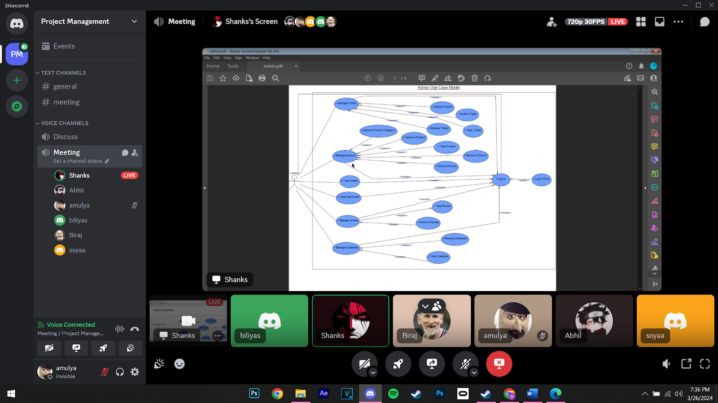

**Day 11(03/28/24): (Online)**

**Objectives:**

* Submission of Use case diagram and functional and non-functional requirements.

**Day 12(04/01/24): (Online)**

**Objectives:**

* Submission of Use case diagram and functional and non-functional requirements.
* Commenced making tables and triggers in Apex

**Day 13(04/02/24): (Physical)**

**Objectives:**

* Discussion on how to further proceed on the project
* Division on individual work (HTML, CSS)
* Table created in the database

**Day 14(04/08/24): (Physical)**

**Objectives:**

* Checked on individual progress.
* Discussion on what changes should be made in HTML and CSS
* Triggers were created in the database

**Day 15(04/09/24): (Physical)**

**Objectives:**

* Finalized the HTML and CSS work and decided how to combine individual works.
* Individual work was pushed, creating each folder in the GIT hub

**Day 16(04/11/24): (Physical)**

**Objectives:**

* Discussion on work progress and how to further proceed with the project

**Day 17(04/15/24): (Online)**

**Objectives:**

* Started maintaining schedules on MS Project

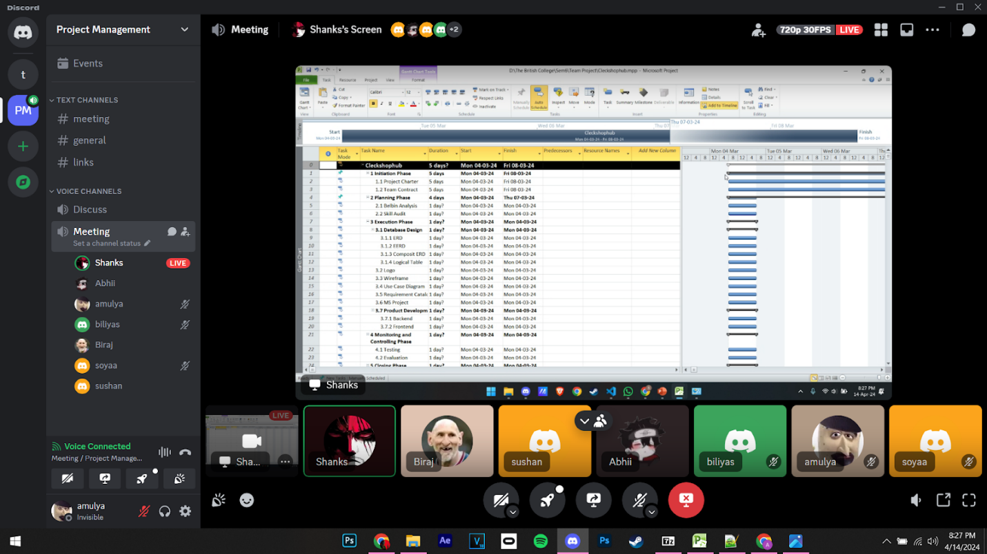

**Day 18(04/18/24): (Online)**

**Objectives:**

* Finalized ms project
* Made necessary changes in slides and word file for wip

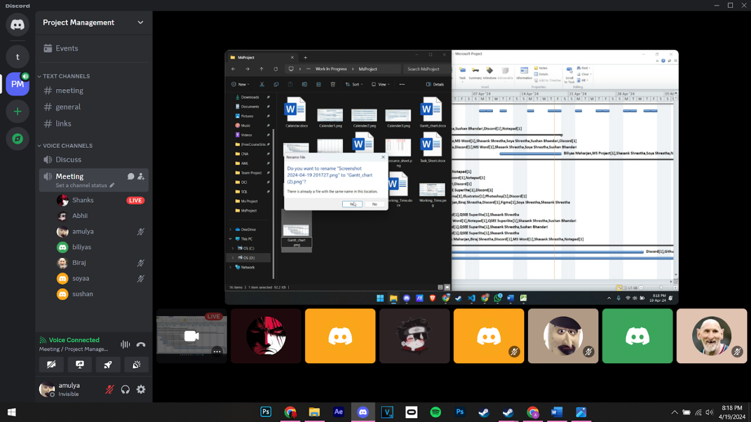

**Day 19(04/19/24): (Physical)**

**Objectives:**

* Finalized ms project
* Made necessary changes in slides and word file for wip

# 2. Planning Phase

## 2.1 Belbin Analysis

Group Belbin Analysis

|  |  |  |
| --- | --- | --- |
|  | **Team Belbin’s Analysis** |  |
| Primary Role | Abhisek Poudel | Plant |
| Amulya Shrestha | Resource Investigator |
| Biliyas Maharjan | Team Worker |
| Biraj Shrestha | Co-Ordinator |
| Shashank Shrestha | Co-Ordinator |
| Soya Shrestha | Team Worker |
| Sushan Bhandari | Implementer |
| Secondary Role | Abhisek Poudel | Resource Investigator |
| Amulya Shrestha | Plant |
| Biliyas Maharjan | Implementer |
| Biraj Shrestha | Complete Finisher |
| Shashank Shrestha | Specialist |
| Soya Shrestha | Monitor Evaluator |
| Sushan Bhandari | Co-Ordinator |
| Least Likely Role | Abhisek Poudel | Shaper |
| Amulya Shrestha | Shaper |
| Biliyas Maharjan | Monitor Evaluator |
| Biraj Shrestha | Plant |
| Shashank Shrestha | Complete Finisher |
| Soya Shrestha | Shaper |
| Sushan Bhandari | Specialist |

Individual Belbin Analysis

|  |  |  |
| --- | --- | --- |
|  | **Individual Belbin’s Analysis** | |
| Primary role | Abhisekh Poudel | Plant |
| Secondary role | Abhisek Poudel | Resource Investigator |
| Least likely role | Abhisek Poudel | Shaper |

|  |  |  |
| --- | --- | --- |
|  | **Individual Belbin’s Analysis** | |
| Primary role | Amulya Shrestha | Resource Investigator |
| Secondary role | Amulya Shrestha | Plant |
| Least likely role | Amulya Shrestha | Shaper |

|  |  |  |
| --- | --- | --- |
|  | **Individual Belbin’s Analysis** | |
| Primary role | Biliyas Maharjan | Team Worker |
| Secondary role | Biliyas Maharjan | Implementer |
| Least likely role | Biliyas Maharjan | Monitor Evaluator |

|  |  |  |
| --- | --- | --- |
|  | **Individual Belbin’s Analysis** | |
| Primary role | Biraj Shrestha | Co-Ordinator |
| Secondary role | Biraj Shrestha | Complete Finisher |
| Least likely role | Biraj Shrestha | Plant |

|  |  |  |
| --- | --- | --- |
|  | **Individual Belbin’s Analysis** | |
| Primary role | Shashank Shrestha | Co-Ordinator |
| Secondary role | Shashank Shrestha | Specialist |
| Least likely role | Shashank Shrestha | Complete Finisher |

|  |  |  |
| --- | --- | --- |
|  | **Individual Belbin’s Analysis** | |
| Primary role | Soya Shrestha | Team Worker |
| Secondary role | Soya Shrestha | Monitor Evaluator |
| Least likely role | Soya Shrestha | Shaper |

|  |  |  |
| --- | --- | --- |
|  | **Individual Belbin’s Analysis** | |
| Primary role | Sushan Bhandari | Implementer |
| Secondary role | Sushan Bhandari | Co-Ordinator |
| Least likely role | Sushan Bhandari | Specialist |

## 2.2 Skill Audit

Team Skill Audit

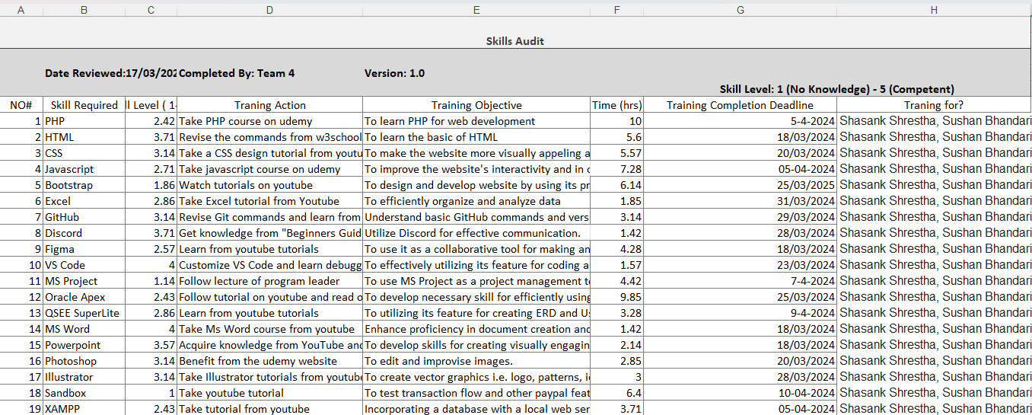

Individual Skill Audit



Figure 1:Abhishek Poudel individual skill audit



Figure 2:Amulya Shrestha individual skill audit

Figure 3:Biliyas Maharjan individual skill audit



Figure 4:Biraj Shrestha individual skill audit

Figure 5:Shasank Shrestha individual skill audit



Figure 6:Soya Shrestha individual skill audit



Figure 7:Sushan Bhandari individual skill audit

## 2.3 Project Management

### Gantt chart

### Timeline

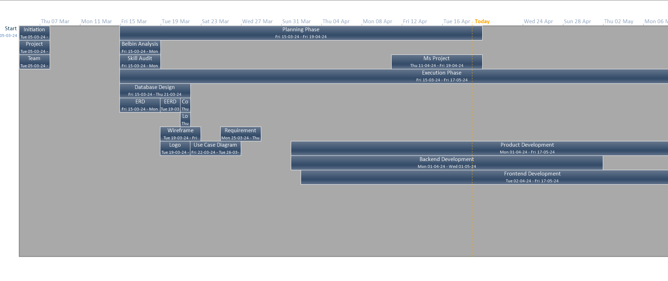

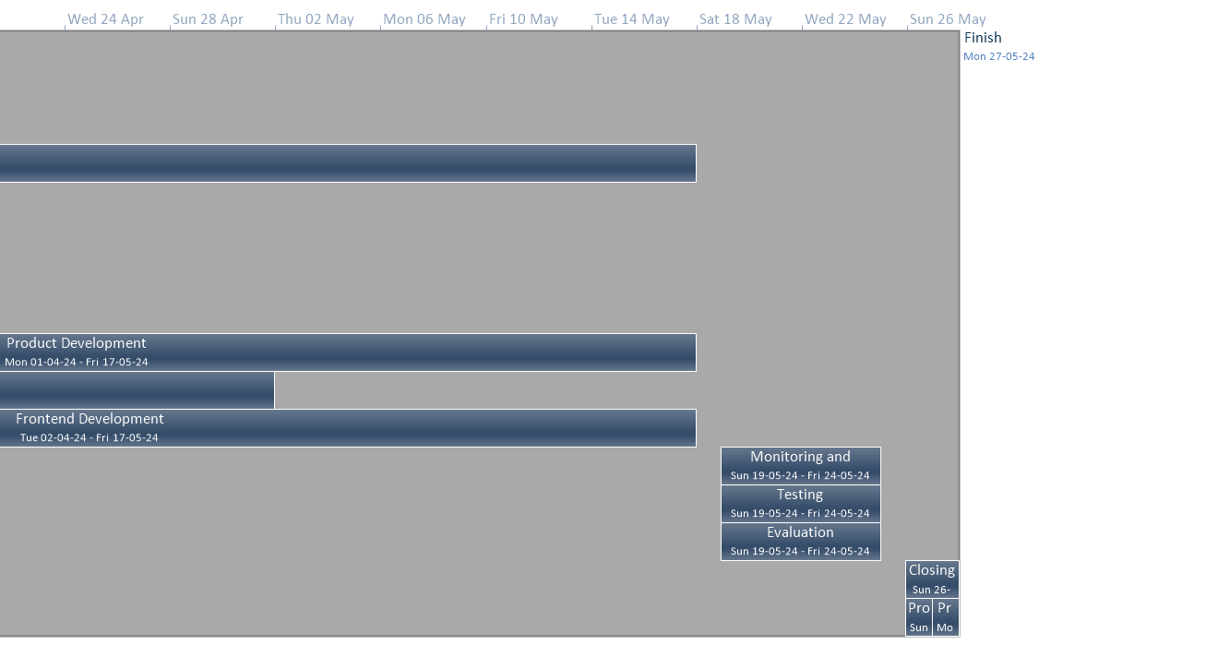

### A screenshot of a computer Description automatically generatedCalendar

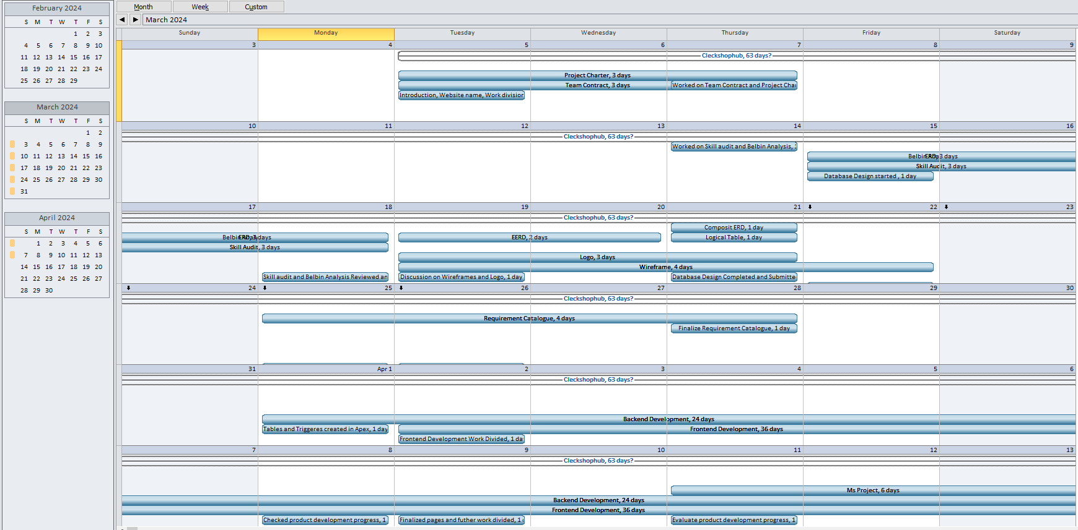

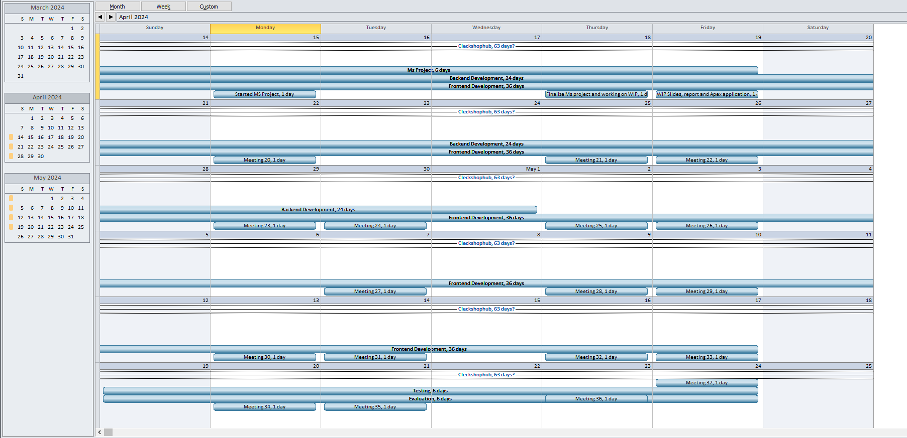

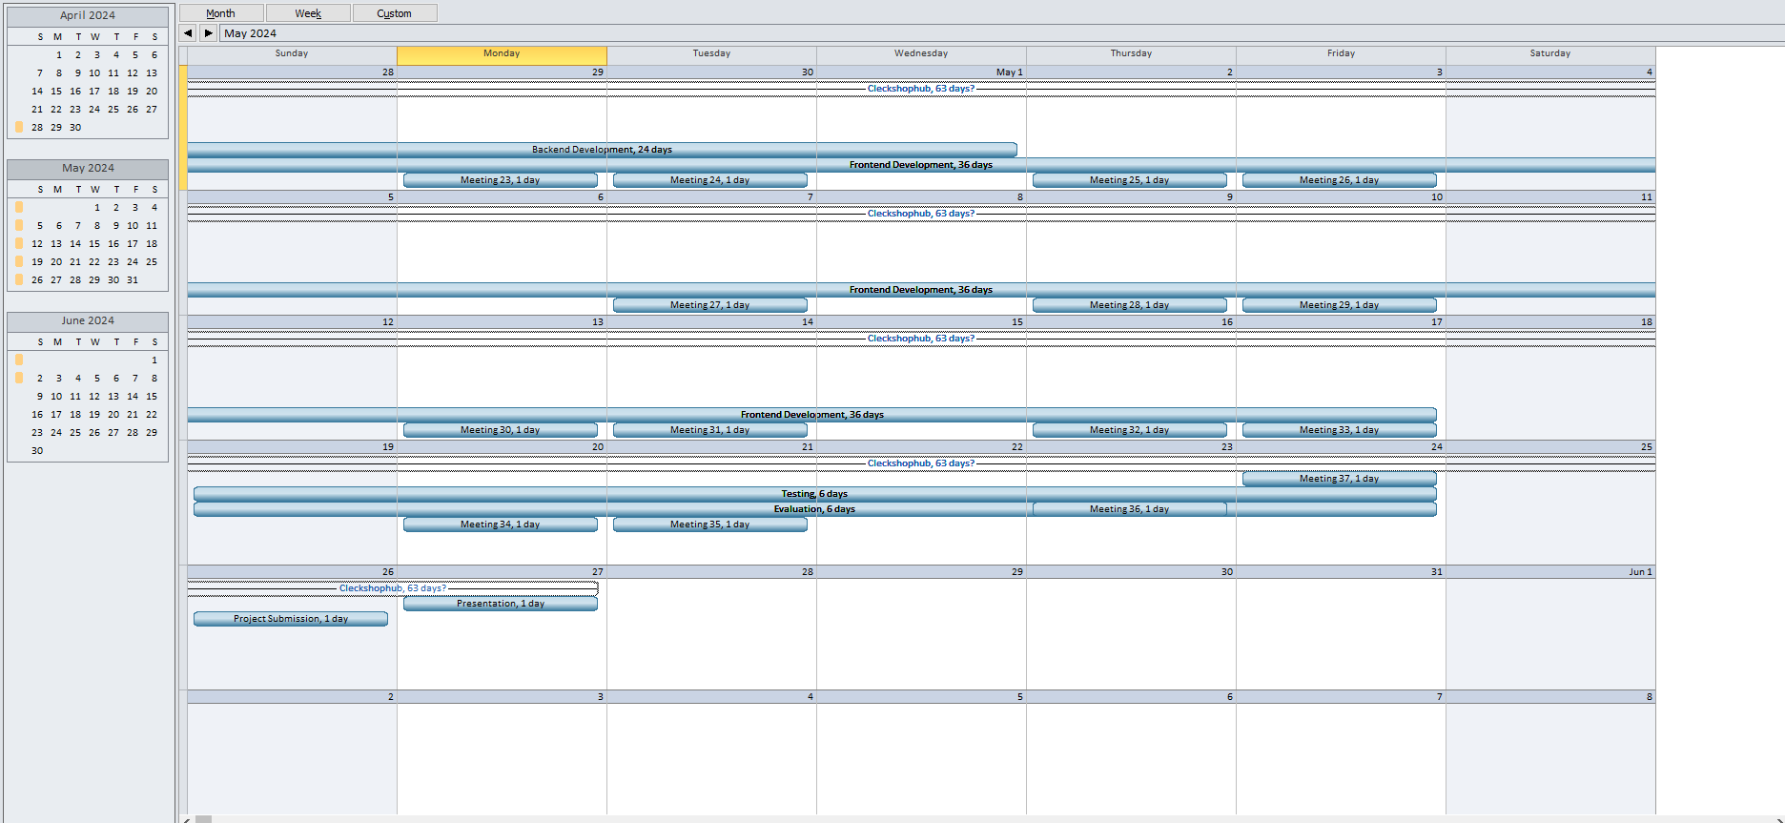

### Resource Sheet

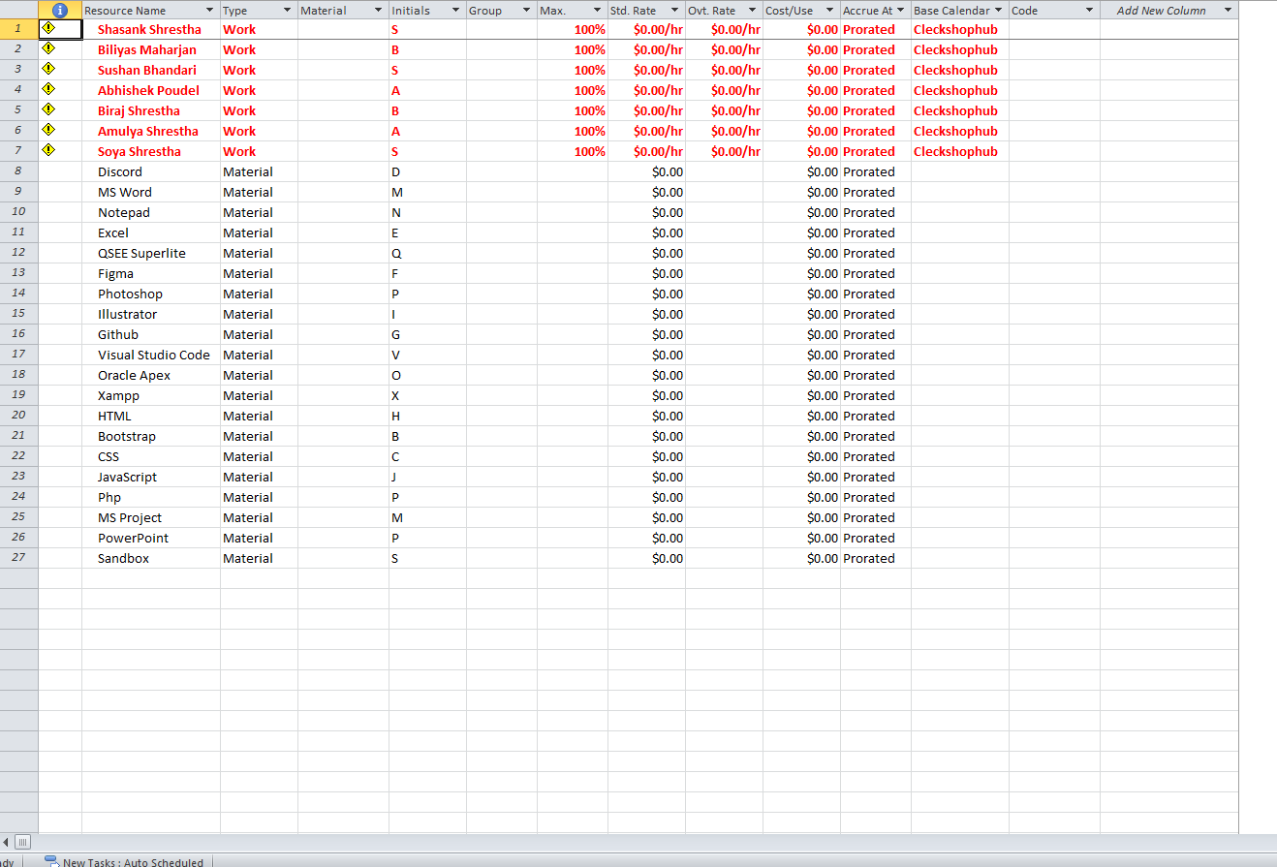



### A computer screen shot of a computer Description automatically generatedChange working time

### Communication Tools Used:

#### Discord

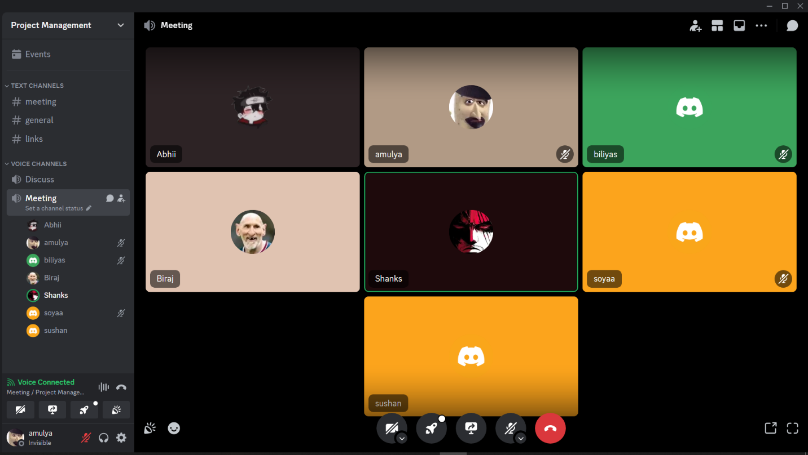

#### GitHub

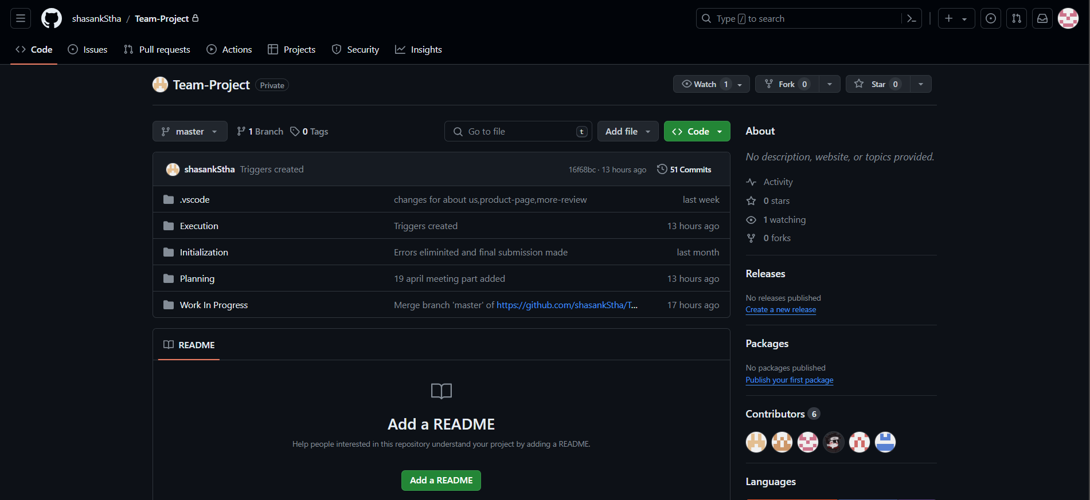

# 3. Execution

## 3.1 Entity Relationship Diagram (ERD)

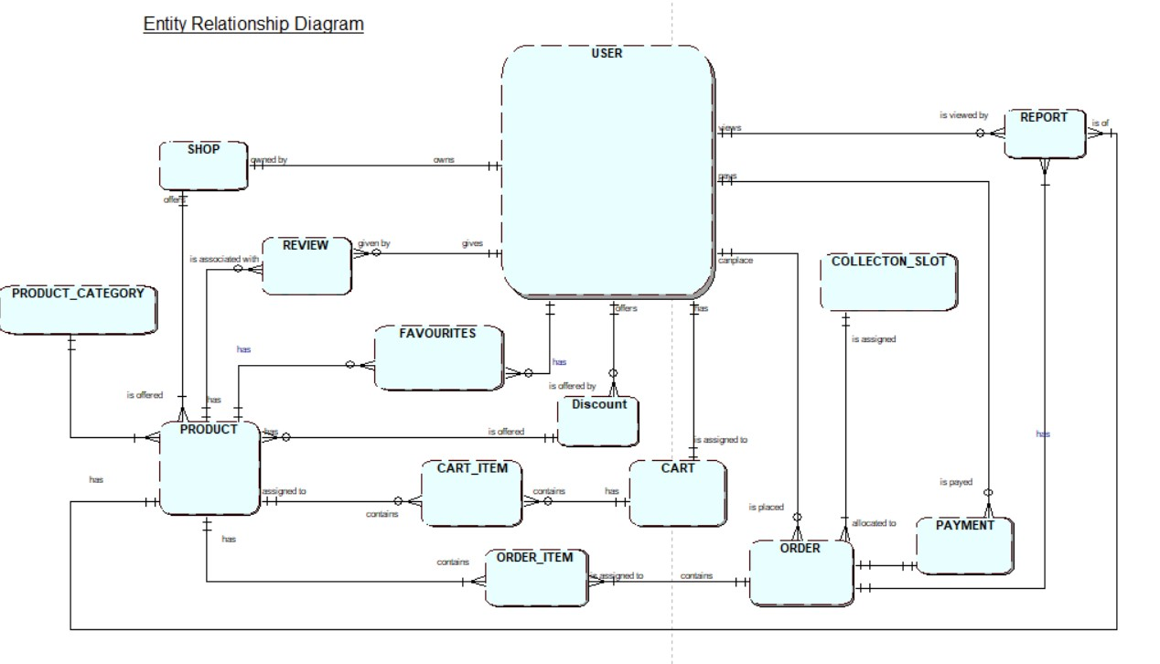

## 3.2 Extended Entity Relationship Diagram (EERD)

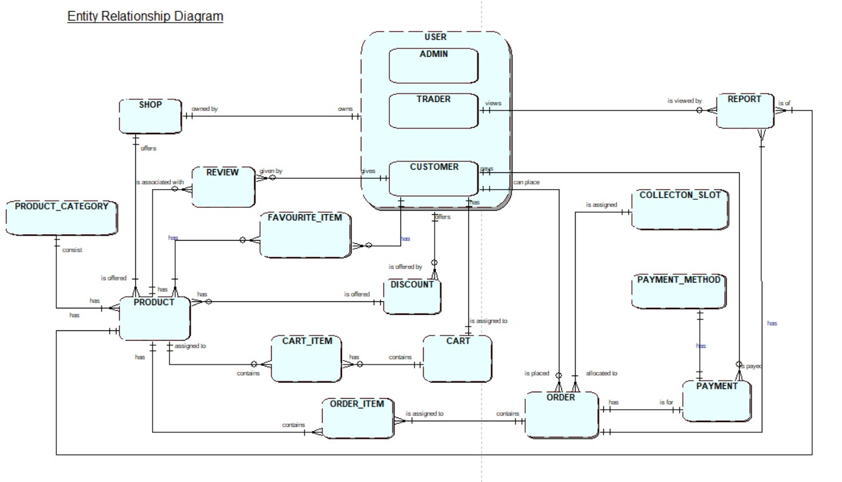

## 3.3 Composite Model

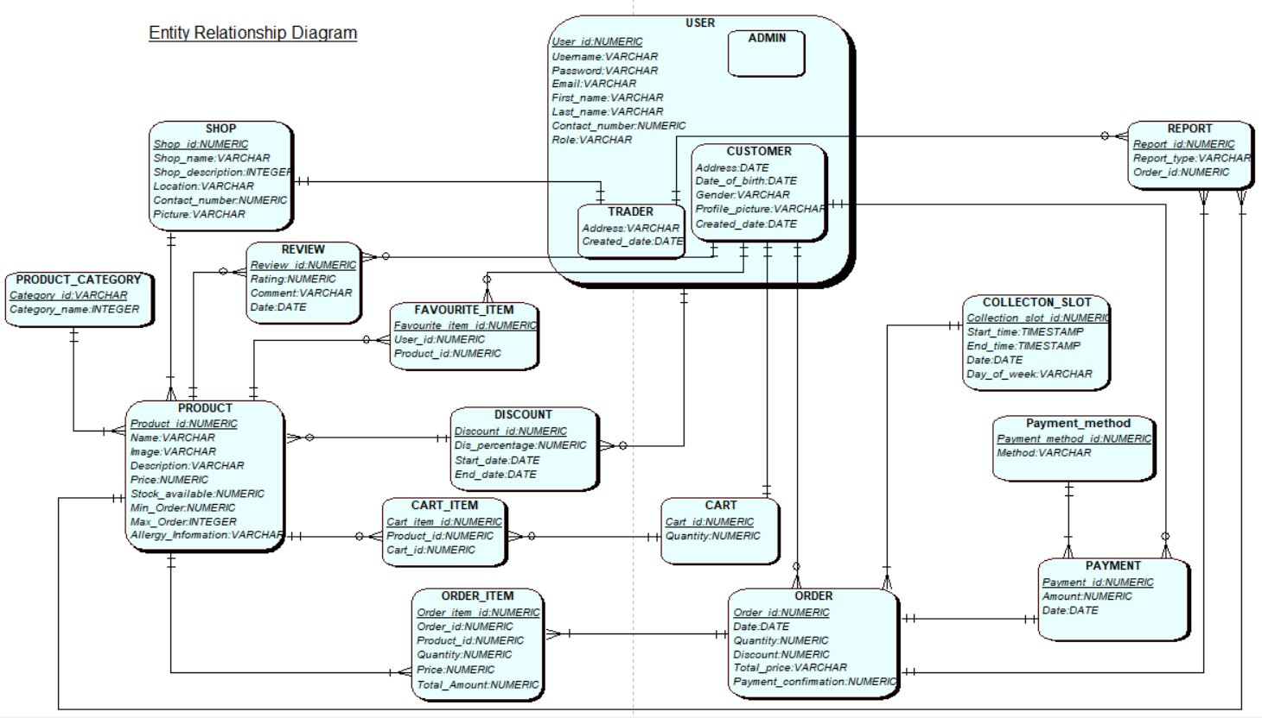

## 3.4 Logical Table

1. USER(**User_id**, Username, Password, Email, First_name, Last_name, Contact_number, Role)
2. ADMIN(***User_id***)
3. TRADER(***User_id***, Address, Created_date, Last_loggedin_date)
4. CUSTOMER(***User_id,*** Address, Date_of_birth, Gender, Profile_picture, Created_date, Last_loggedin_date)
5. SHOP(**Shop_id**, Shop_name, Location,Shop_Description, Picture, Contact_number, *User_id*)
6. PRODUCT(**Product_id**, Name, Image, Description, Price, Stock_Available, Min_Order, Max_Order, Allergy_Information, *Shop_id, Category_id,Discount_id)*
7. PRODUCT_CATEGORY(**Category_id**, Category_name)
8. REVIEW(**Review_id**, Rating, Comment, Date, *Product_id, User_id)*
9. FAVOURITE_ITEM(**Favourite_item_id**, *User_id*, *Product_id*)
10. DISCOUNT(**Discount_id**, Dis_percentage, Start_data, End_date, *User_id*)
11. CART(**Cart_id**, Quantity, *User_id*)
12. CART_ITEM(**Cart_item_id**, *Cart_id, Product_id)*
13. ORDER(**Order_id**, Date, Quantity, Discount, Total_price, Payment_confirmation, *User_id, Collection_Slot_id)*
14. ORDER_ITEM(**Order_item_id**, Quantity, Price, Discount, Total_Amount, *Order_id, Product_id*)
15. COLLECTION_SLOT(**Collection_slot_id**, Start_time, End_time, Date, Day_of_week)
16. PAYMENT(**Payment_id**, Amount, Date, *User_id, Order_id, Payment_method_id*)
17. PAYMENT_METHOD(**Payment_method_id**, Method)
18. REPORT(**Report_id**, Date, Report_type, *User_id, Order_id, Product_id)*

## 3.4 Use Case Diagram

* + - Overall Use Case Diagram

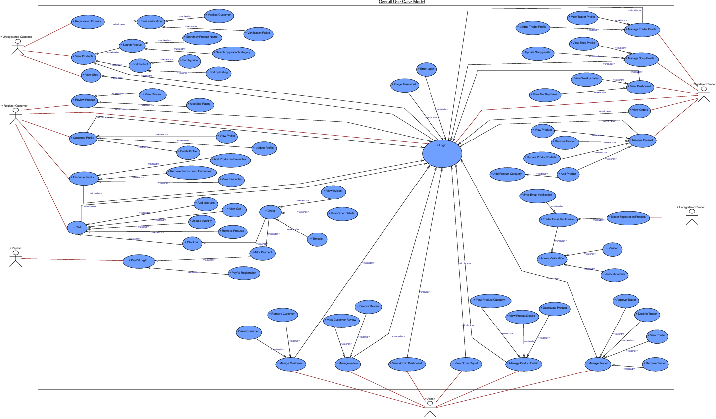

* + - Admin Use Case Diagram

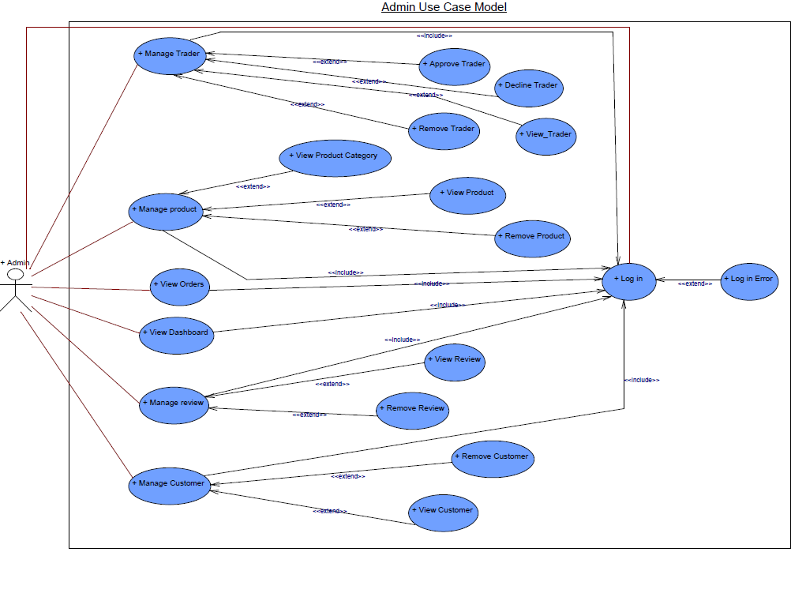

* + - Customer Use Case Diagram

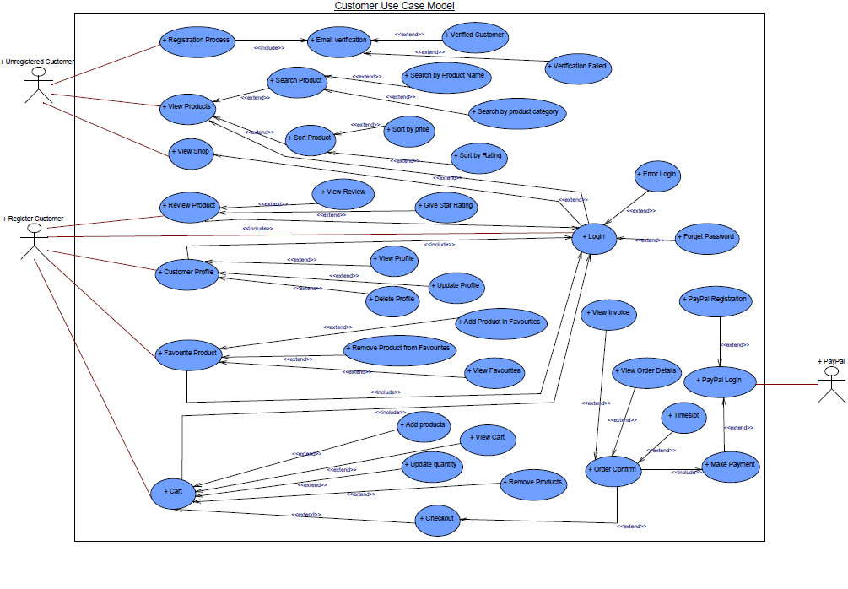

* + - Trader Use Case Diagram

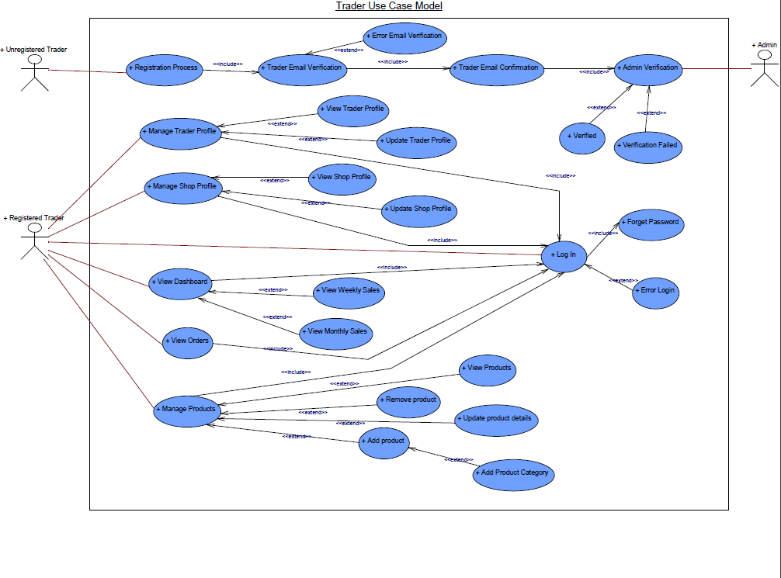

## 3.5 Requirement Catalogue

#### A: Product

|  |  |  |
| --- | --- | --- |
| **Requirement ID** | **Description** | **MoSCoW** |
| **A1** | **All products need details.** |  |
| A1-01 | Each product should have their name, price, stock information, minimum order, and maximum order. | M |
| A1-02 | Products should be associated with a specific shop. | M |
| A1-03 | Product should have a product category. | M |
| A1-04 | Product should have image and allergy information. | S |
| A1-05 | Product should display average rating and review count. | S |
| A1-06 | Products can have discount applied to them. | C |
| **A2** | **An interface to navigate product and shop.** |  |
| A2-01 | Users should be able to see shop details like name, location, description etc. | M |
| A2-02 | Users should be able to search products by product name or product category. | M |
| A2-03 | Users should be able to search for products by shop. | S |
| A2-04 | Users should be able to filter products based on price and rating. | S |
| **A3** | **An interface to add products in cart and wish list.** |  |
| A3-01 | Users should be logged in to add products to their cart. | M |
| A3-02 | Users should be able to add up to 20 different items in the cart at a time. | M |
| A3-03 | Users should be able to view items in their cart. | M |
| A3-04 | Users should be able to add/ remove product from their wish list or favorites list. | S |
| A3-05 | Users should be able to increase or decrease the quantity of products from the cart. | C |
| **A4** | **An interface for review and rating for product.** |  |
| A4-01 | Users should be able to leave a textual review of the product. | S |
| A4-02 | Users should be able to give star ratings to a product. | S |
| A4-03 | Products should have a date of reviewed. | C |

#### B: Customer

|  |  |  |
| --- | --- | --- |
| **Requirement ID** | **Description** | **MoSCoW** |
| **B1** | **An interface to register for new user.** |  |
| B1-01 | User should provide all required details i.e. name, address, contact number etc. to register. | M |
| B1-02 | Email verification should be required during registration. | M |
| B1-03 | Password should be 8 to 32 characters long. | S |
| B1-04 | Password should contain an uppercase, number and a special character. | C |
| **B2** | **An interface for user login.** |  |
| B2-01 | User should be able to log in using their registered credentials. | M |
| B2-02 | User should be able to reset their password via web interface. | S |
| B2-03 | User should be able to reset their password via email verification if he/she forgets. | C |
| **B3** | **An interface to view and update profile.** |  |
| B3-01 | User should be able to view and update their profile information. | M |
| B3-02 | User should be able to change their password. | S |
| B3-03 | User should be able to upload or remove profile picture. | C |
| **B4** | **Customer should be able to view product.** |  |
| B4-01 | Customer should be able to search and browse products. | M |
| B4-02 | Customers should be able to view product details. | M |
| B4-03 | Customer should be able to sort and filter products. | S |
| B4-04 | Customers should be able to view product review and ratings | S |
| B4-05 | Customers should be able to view related products. | S |
| B4-06 | Customers should be able to view product availability. | C |
| **B5** | **Customer has access to cart.** |  |
| B5-01 | Customer should be logged in to access cart. | M |
| B5-02 | Customers should be able to view the total cost of items in their cart. | M |
| B5-03 | Customers should be able to remove all the products from cart using “Clear All” button. | S |
| B5-04 | Customers should be able to increase or decrease the quantity of product in the cart. | S |
| B5-05 | Customer should be able to save their cart for later. | C |
| **B6** | **Customer has wish list.** |  |
| B6-01 | Customers can add or remove product from their wish list. | C |
| **B7** | **An interface to place order.** |  |
| B7-01 | Customer should be able to select a collection time slot while placing order. | M |
| B7-02 | Customer should be able to pay through PayPal. | M |
| B7-03 | Customer should get a notification about order confirmation. | S |
| B7-04 | Customer should be able to cancel their order. | C |
| **B8** | **An interface to review product.** |  |
| B8-01 | Customer should be able to leave a review and star rating on the product they have purchased. | M |
| B8-02 | Customer should be able to edit their review and ratings. | C |
| **B9** | **An interface to view order details.** |  |
| B9-01 | Customer should be able to view their order details. | M |
| B9-02 | Customer should be able to view their order history. | C |

#### C: Trader

|  |  |  |
| --- | --- | --- |
| **Requirement ID** | **Description** | **MoSCoW** |
| **C1** | **An interface for trader registration and login.** |  |
| C1-01 | Trader should be able to register with their shop information. | M |
| C1-02 | Traders should be able to log in using their registered credentials. | M |
| C1-03 | Traders should be able to reset their passwords via email verification if they forget their passwords. | S |
| C1-04 | The registration and login forms should have proper validations. | C |
| C2 | **An interface to view and update profile.** |  |
| C2-01 | Traders should be able to view and update their profile via web interface. | M |
| C2-02 | Traders can view and update their shop information, including descriptions and contact details. | M |
| C2-03 | Traders should be able to change their passwords. | S |
| **C3** | **Trader can manage product and shop.** |  |
| C3-01 | Traders should be able to add new products to their shop. | M |
| C3-02 | Traders should be able to update stock information of the product. | M |
| C3-03 | Traders should be able to update shop information. | M |
| C3-04 | Traders should be able to remove the product. | S |
| C3-05 | Traders should be able to set discounts on their products. | C |
| **C4** | **Access to dashboard and reports.** |  |
| C4-01 | Traders should be able to access the dashboard via website or apex. | M |
| C4-02 | Traders can view details of daily orders. | M |
| C4-03 | Traders can view daily, weekly, and monthly reports. | M |
| C4-04 | Traders can view weekly financial reports. | S |
| C4-05 | Traders can filter reports based on date. | S |
| C4-06 | Traders should be able to export reports in various formats. | C |

#### D: Management

|  |  |  |
| --- | --- | --- |
| **Requirement ID** | **Description** | **MoSCoW** |
| **D1** | **An apex login interface.** |  |
| D1-01 | The administrator should be able to log in via both website and apex. | M |
| **D2** | **Manage trader and user.** |  |
| D2-01 | Admin should be able to view traders. | M |
| D2-02 | Admin should be able to view customers. | M |
| D2-03 | Admin should be able to approve or decline a trader register request. | M |
| D2-04 | Admin should be able to remove a trader or customer account. | M |
| D2-05 | Admin should be able to remove a review written by a user. | M |
| D2-06 | Admin should be able to send notifications to traders and users. | C |
| **D3** | **Management reports** |  |
| D3-01 | Admin should have access to various management reports and analytics. | M |
| **D4** | **Payment** |  |
| D4-01 | The system should support integration with payment gateways like PayPal and Stripe. | C |

### Non-Functional Requirement

#### E: Non-Functional

|  |  |
| --- | --- |
| **Requirement ID** | **Description** |
| E1 | The website should respond within an acceptable timeframe to user actions. |
| E2 | The website should be able to handle increasing loads of users and data without sacrificing performance. |
| E3 | User’s accounts should be securely stored and protected against unauthorized access or data breaches. |
| E4 | Properly authenticating users and authorizing access to different parts of the website based on their roles and permission. |
| E5 | Encryption protocols to protect sensitive data such as payment information and personal details. |
| E6 | Websites should run smoothly across different devices and screen sizes. |
| E7 | Reliable backup and recovery procedures to protect against data loss and maintain operations during system failures. |
| E8 | Ensure users to leave feedback, ratings and reviews for products and services. |
|  |  |
| E9 | Recommend products and contents based on individual user preferences, browsing and payment history. |

# 3.7 Logo Design

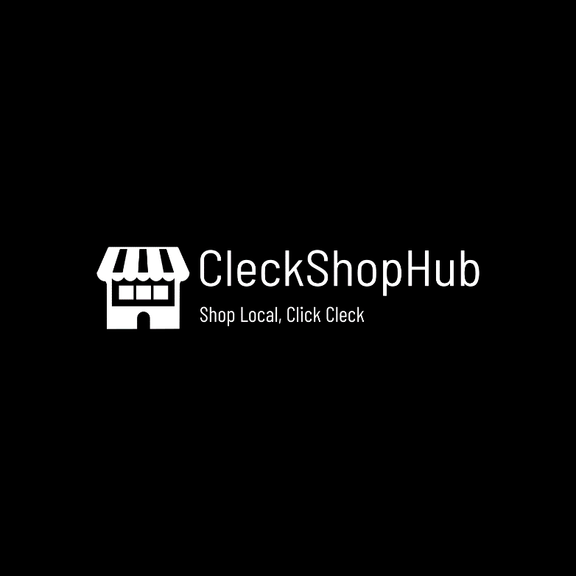



# 3.8 Wireframes

### Home Page and Product Search Page

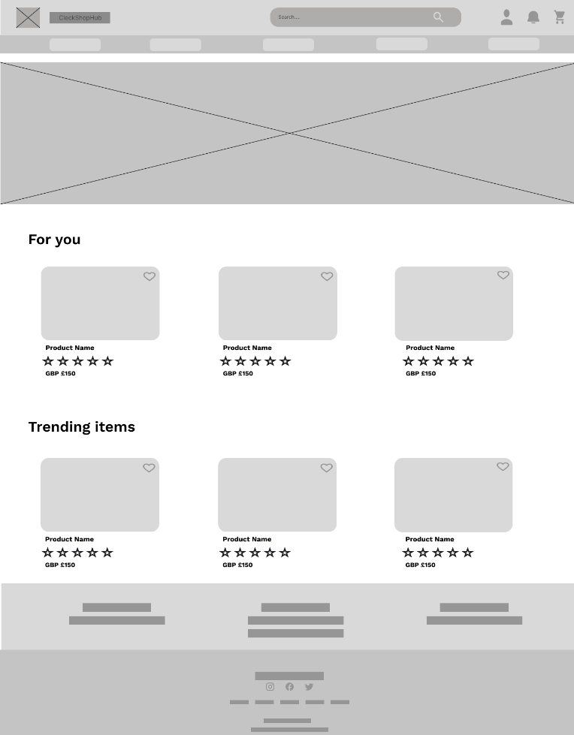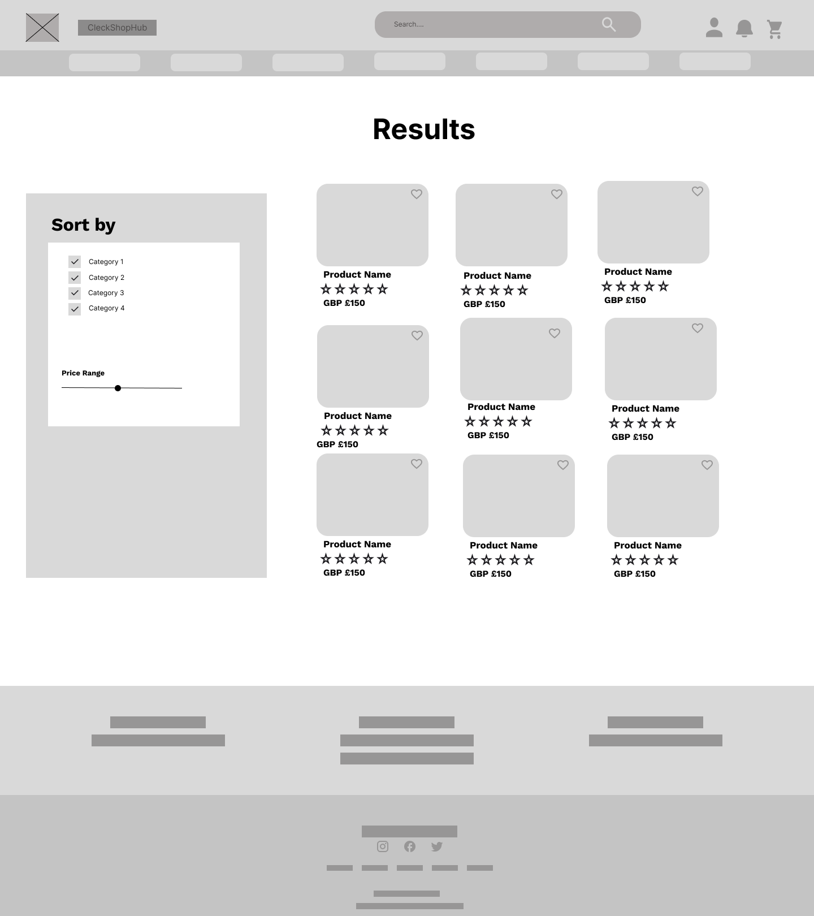

Figure 5: Product search page wireframe

Figure 4: Home Page Wireframe

### Customer Profile and Order History Page

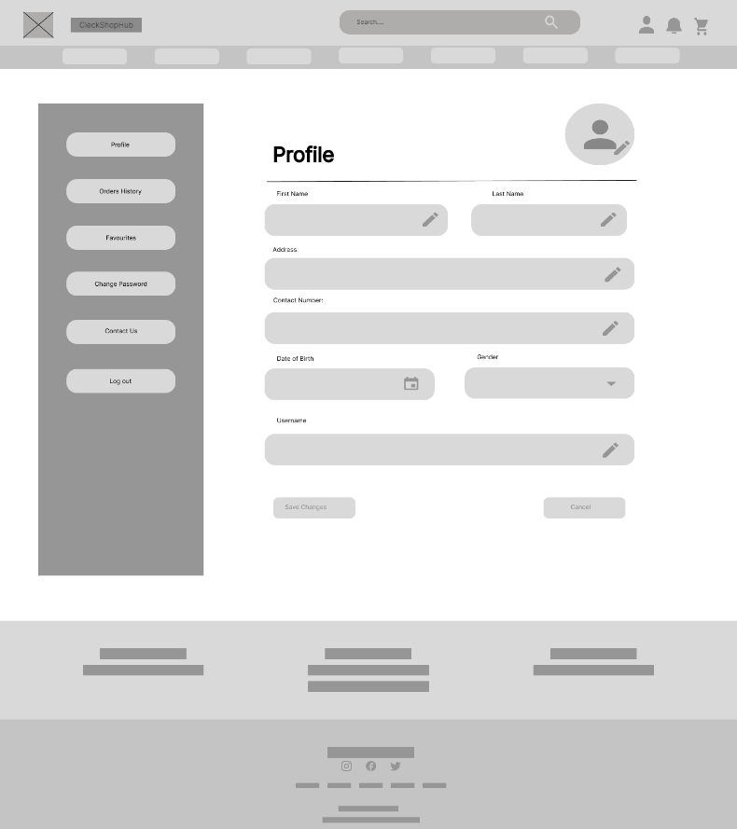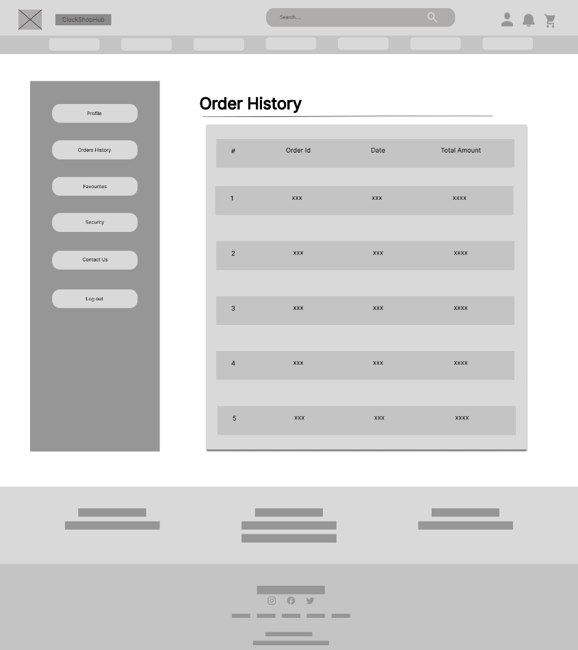

Figure 6:Customer profile wireframe

Figure 7 Order history wireframe

### Shop page

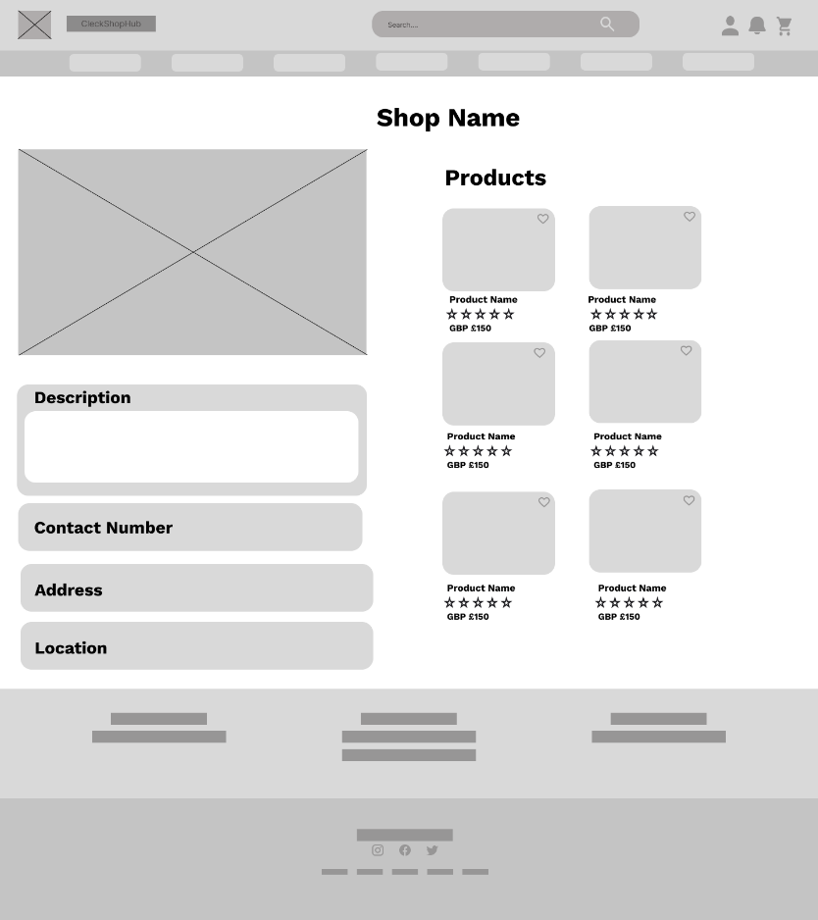

Figure 8:Shop Page wireframe

### Admin Website Dashboard and Database Dashboard

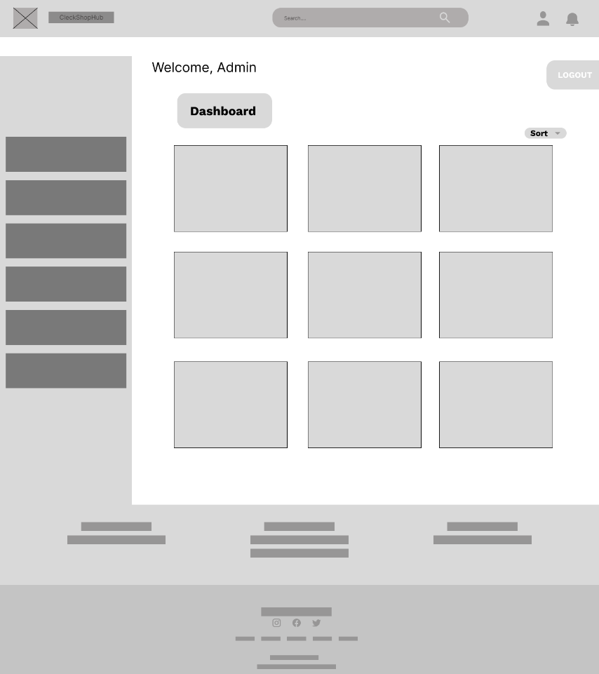

Figure 9: Admin Website Dashboard

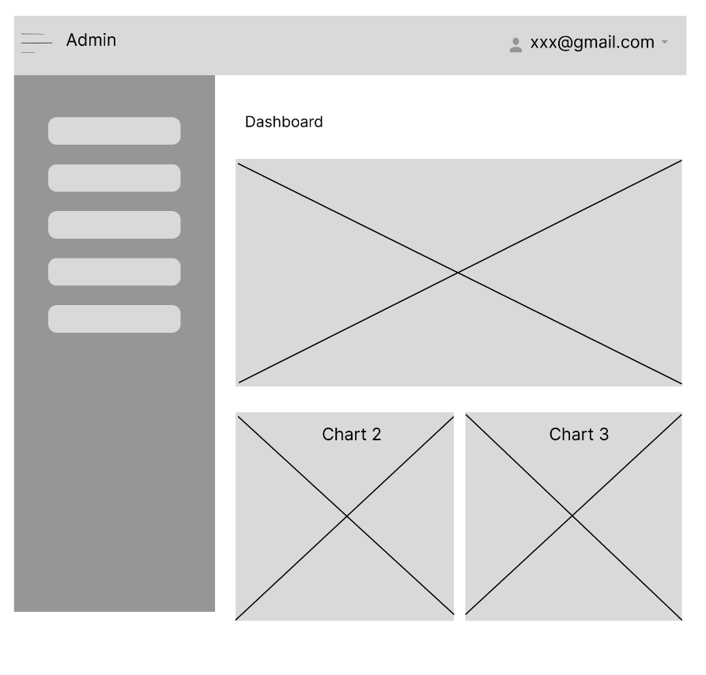

Figure 10: Admin Oracle Apex Dashboard

### Sign up and login for customer

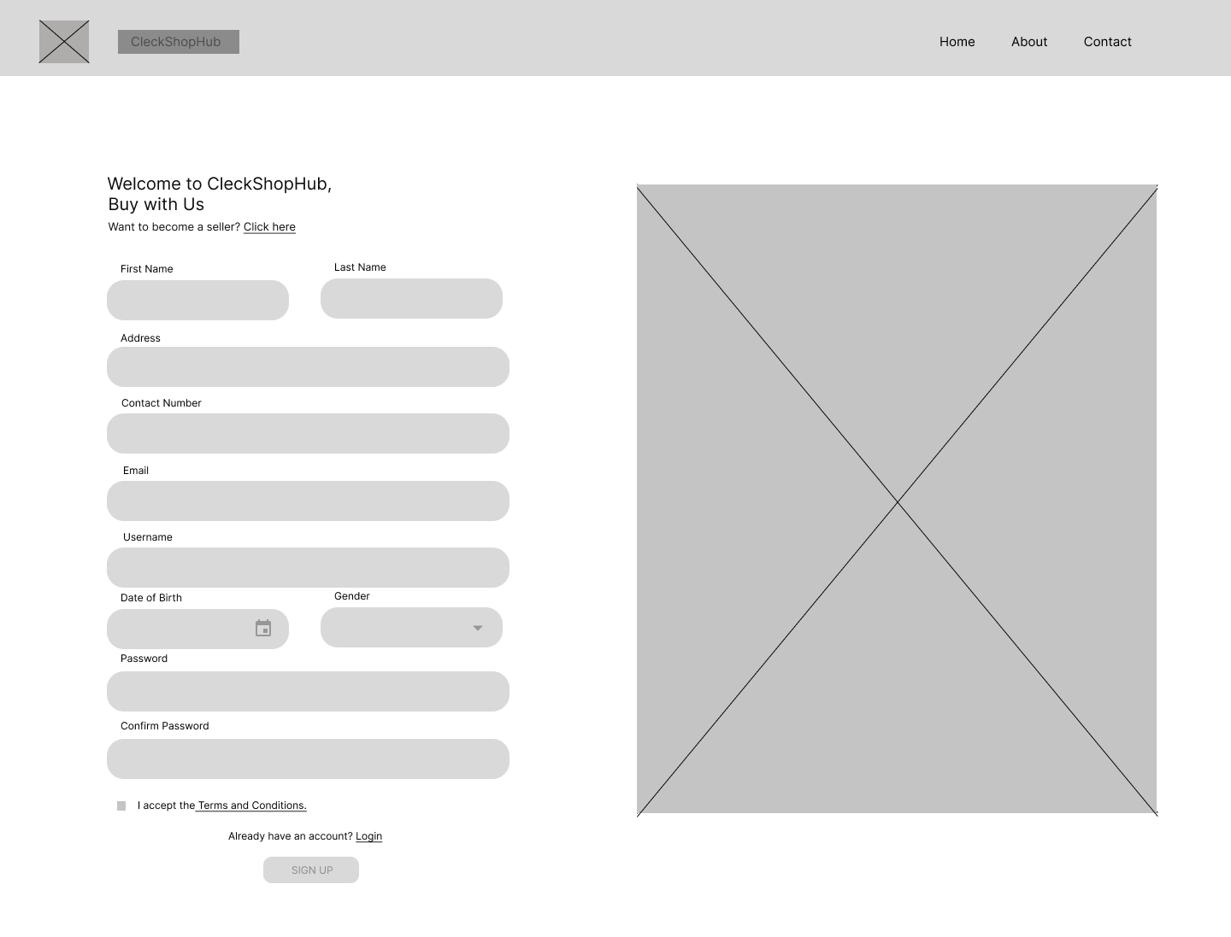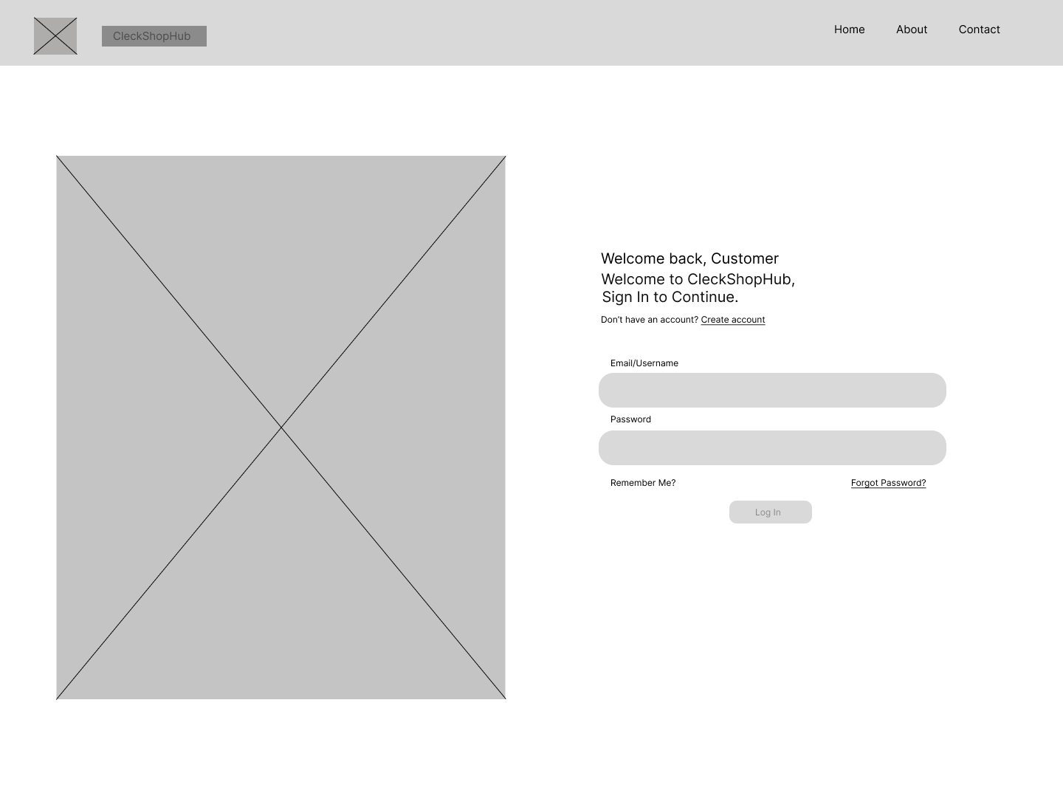

Figure 11: Customer signup

Figure 12: Customer Login

### Sign up and login for Traders

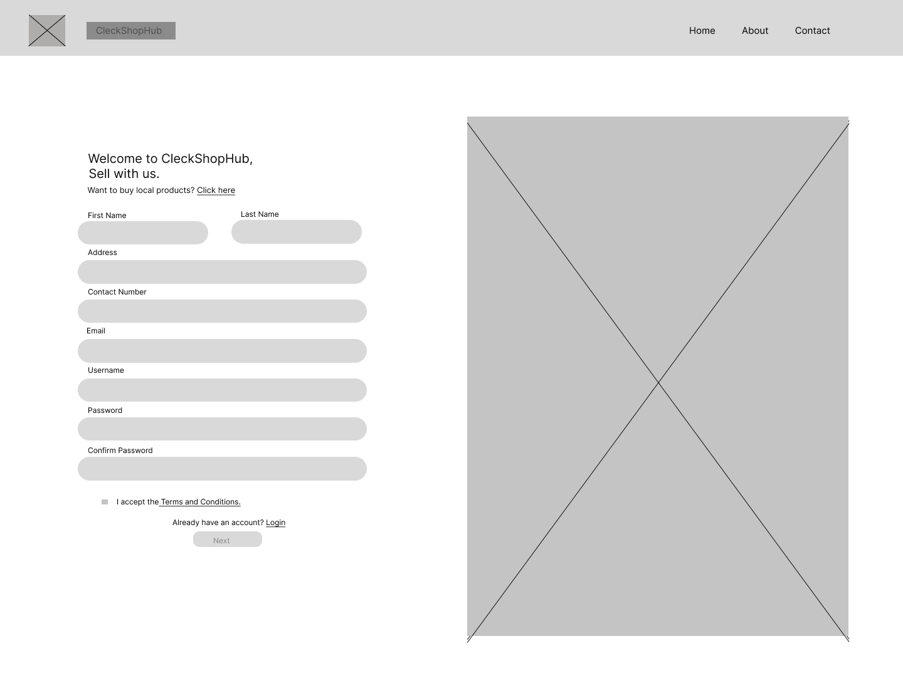

Figure 13: Trader Signup

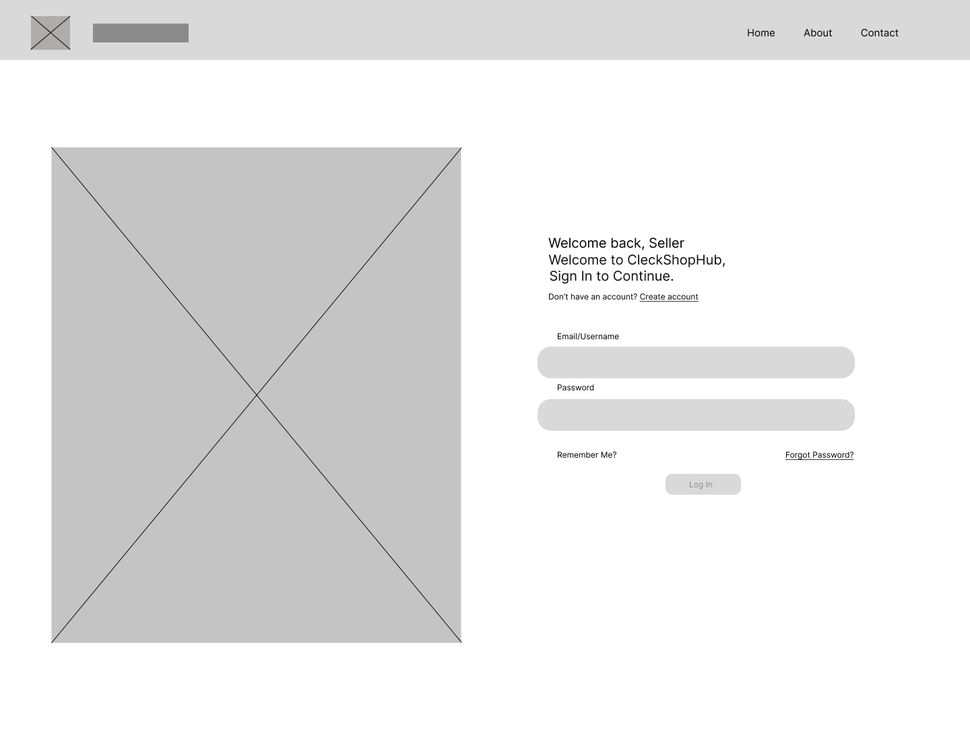

Figure 14: Trader Signin

### Admin Login and shop detail during sign up page

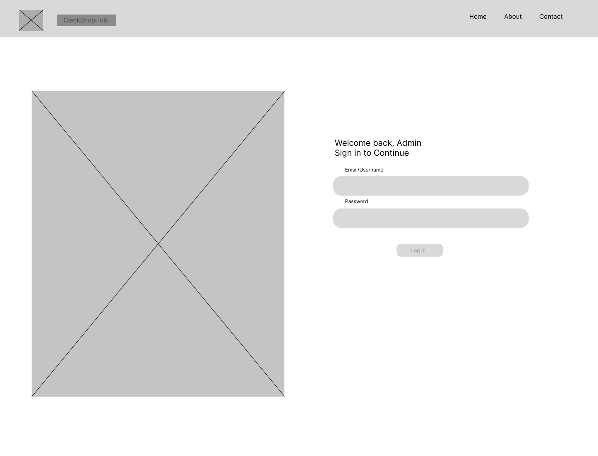

Figure 15: Admin Login

### About Us

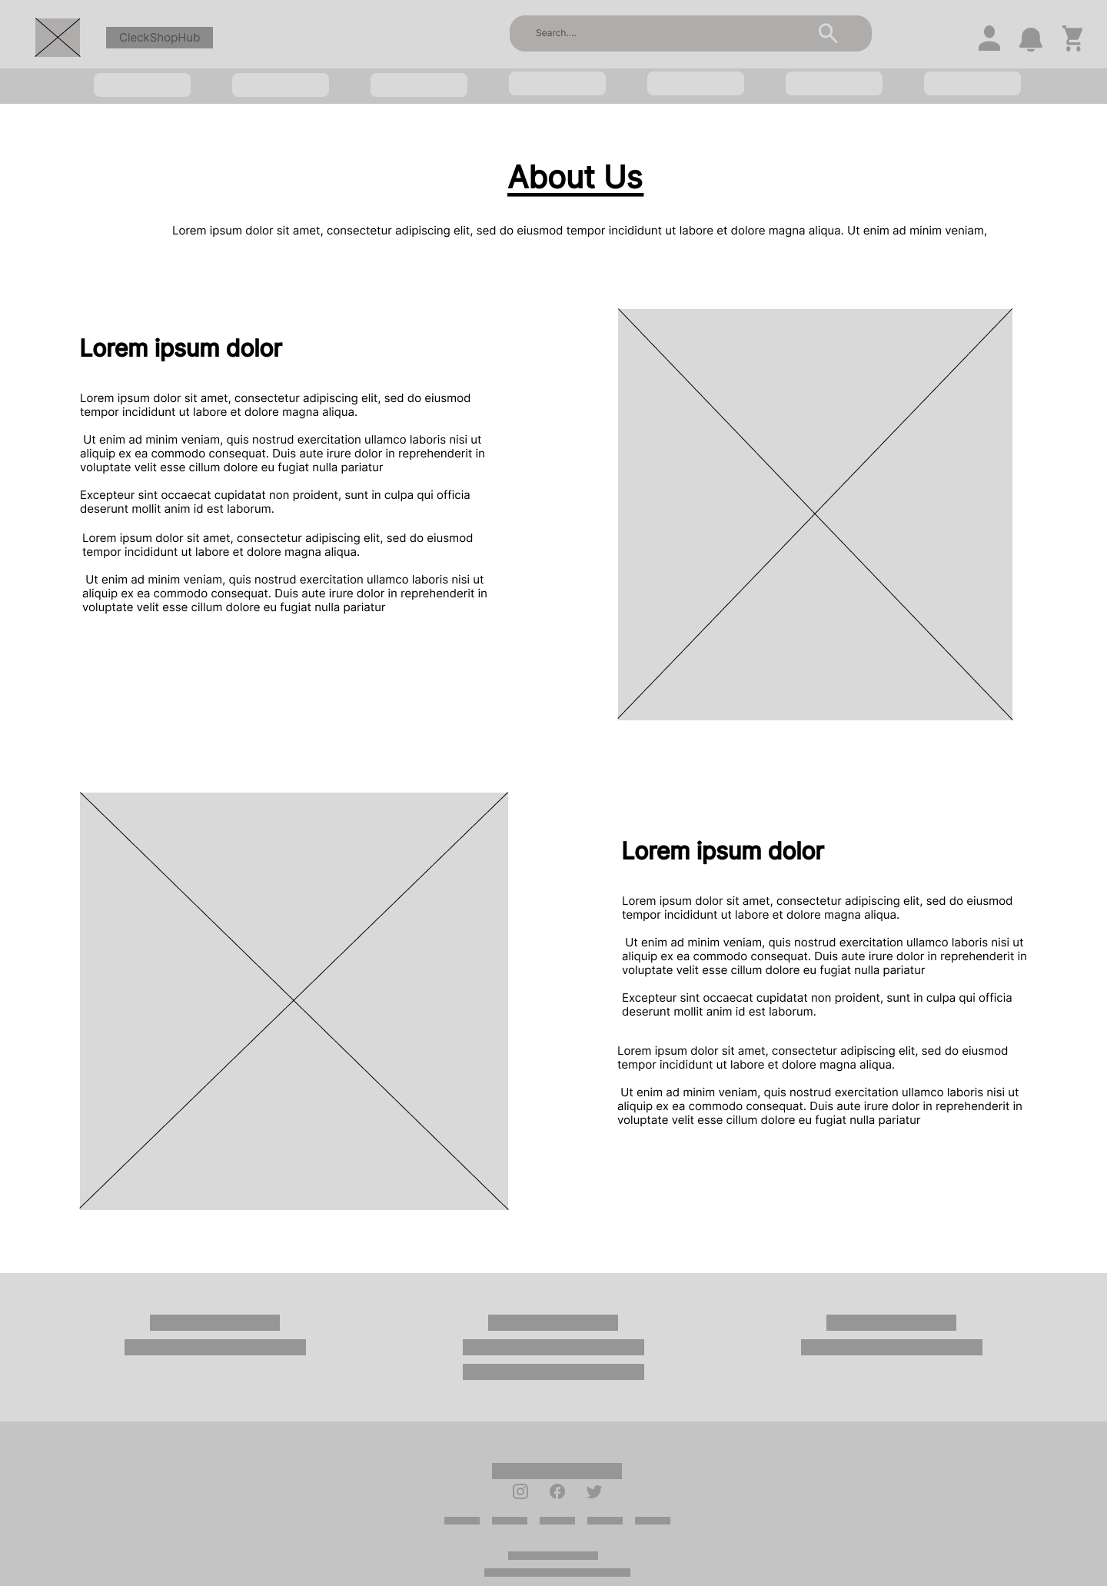

Figure 16: About us

### Contact Us

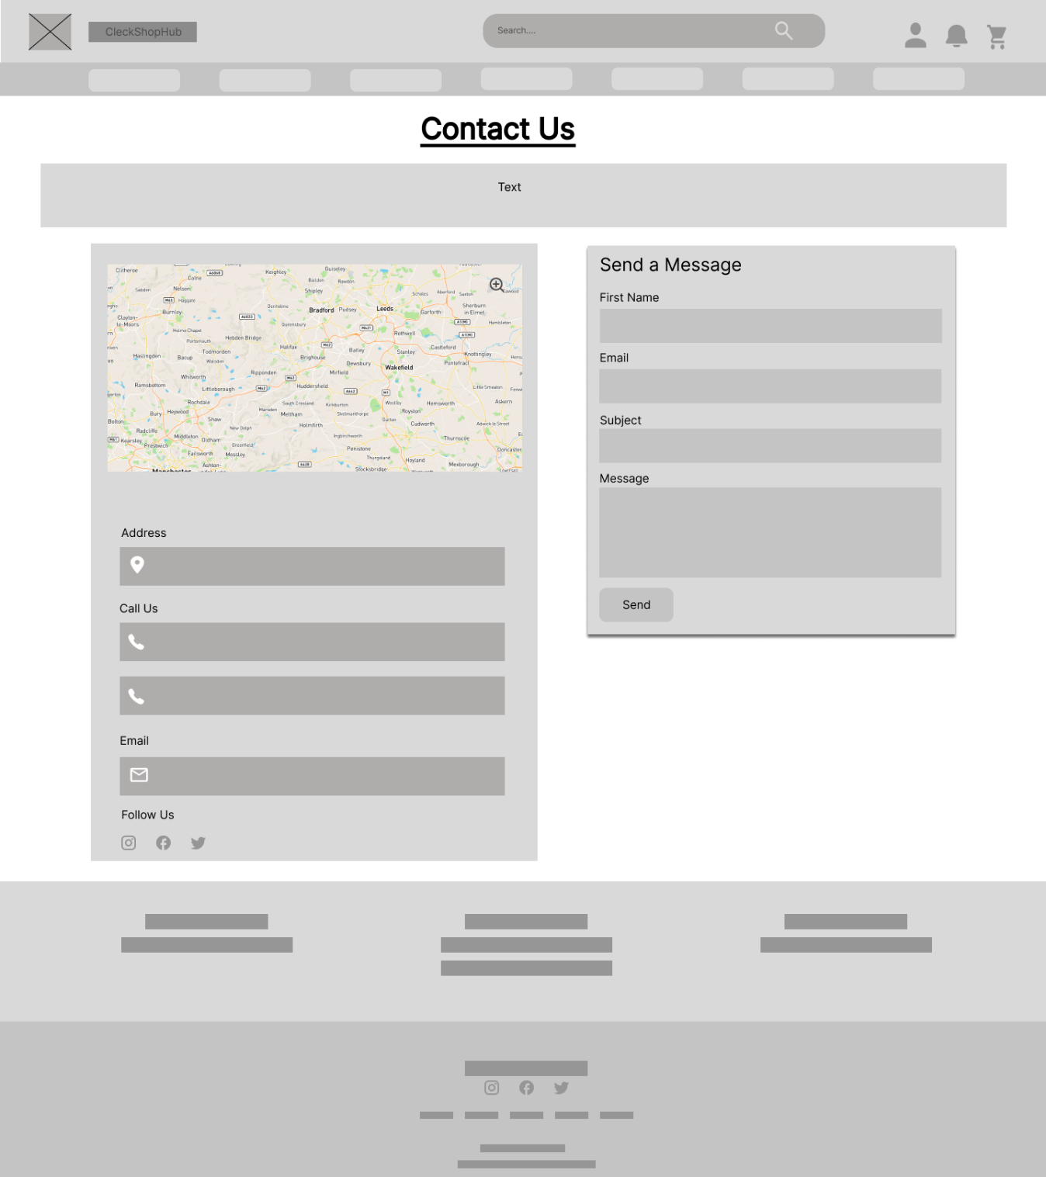

Figure 17: Contact us

# Product Development

## Front End Development

### Homepage:

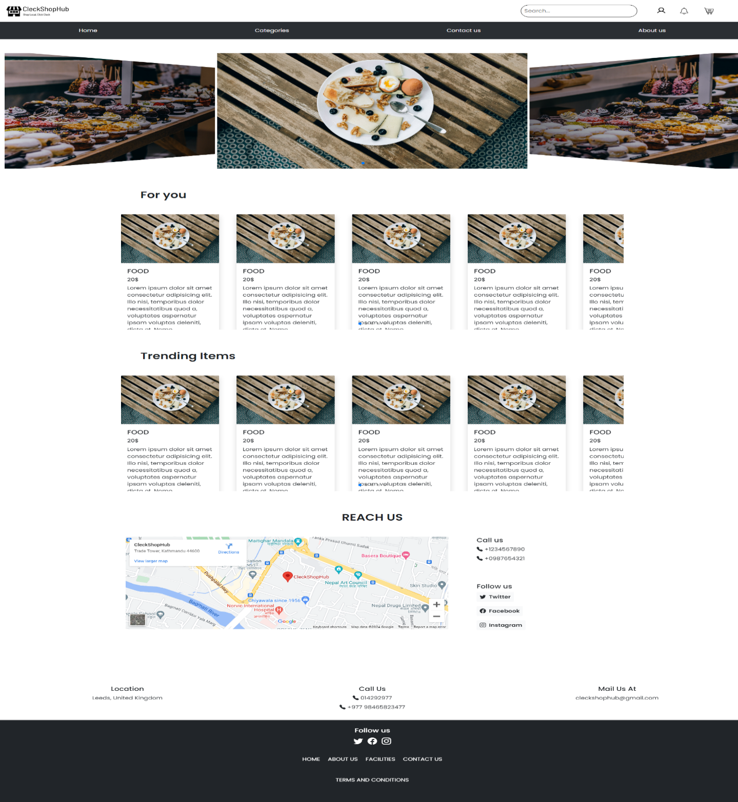

Figure 18: Home page

### Product Page:

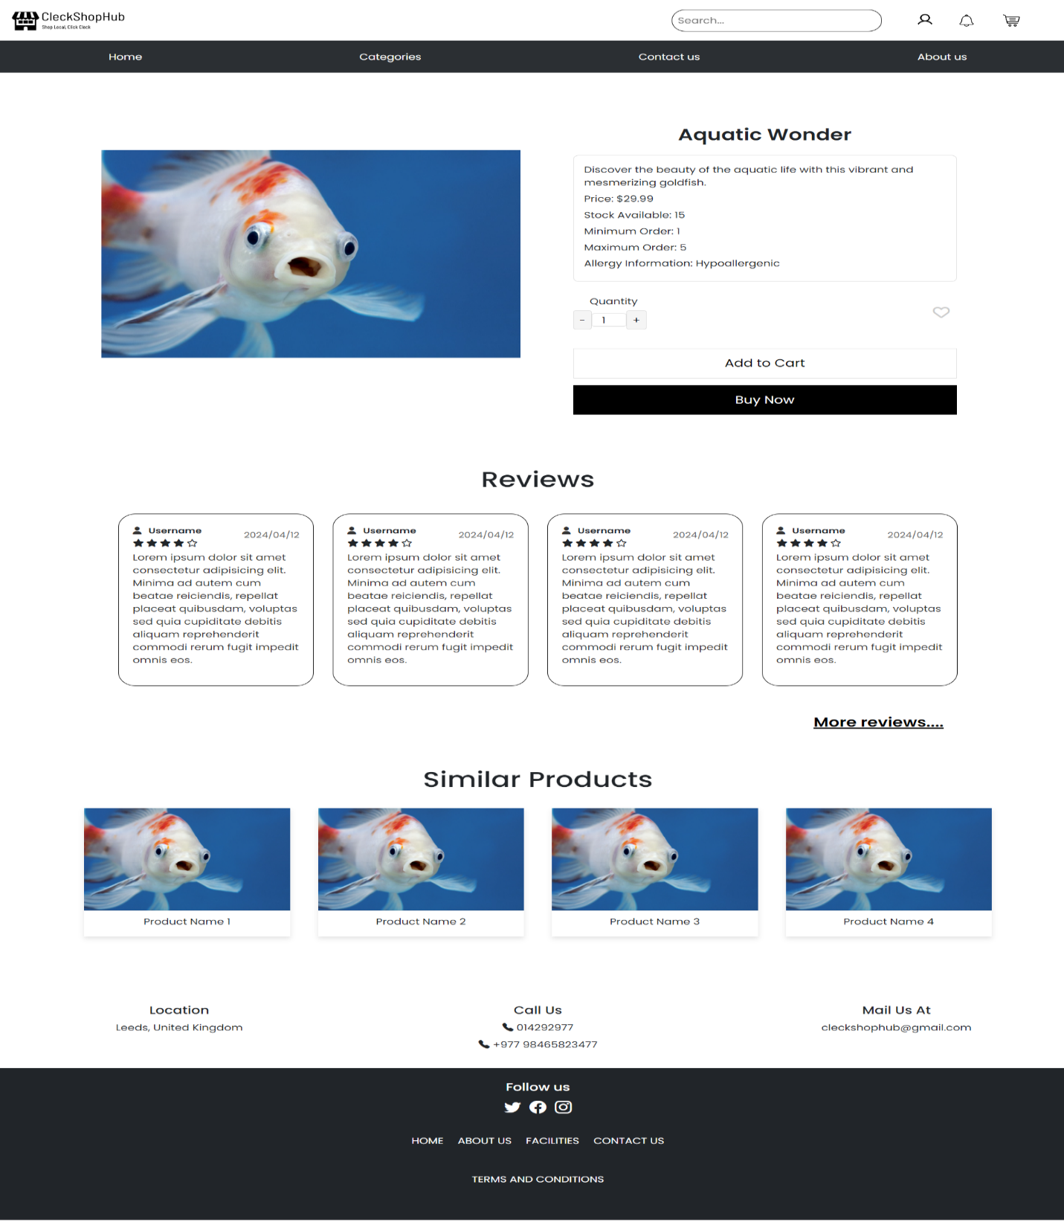

Figure 19: Product page

### User Profile page:

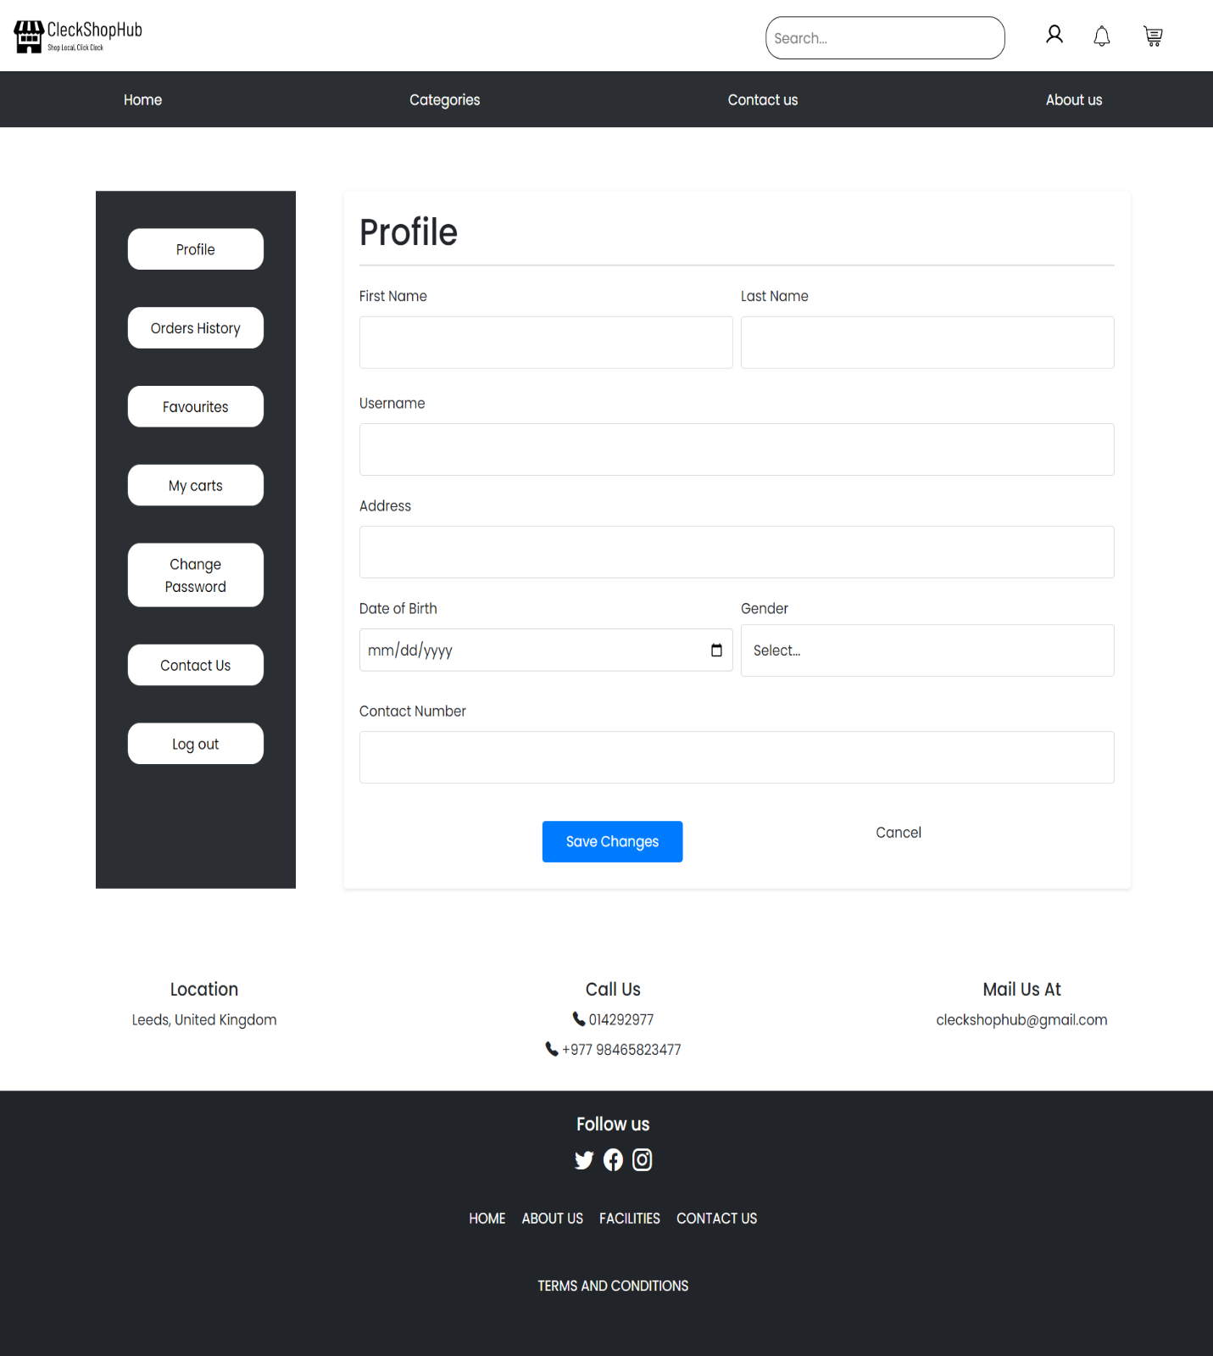

Figure 20: User Profile

### Customer Signup Page:

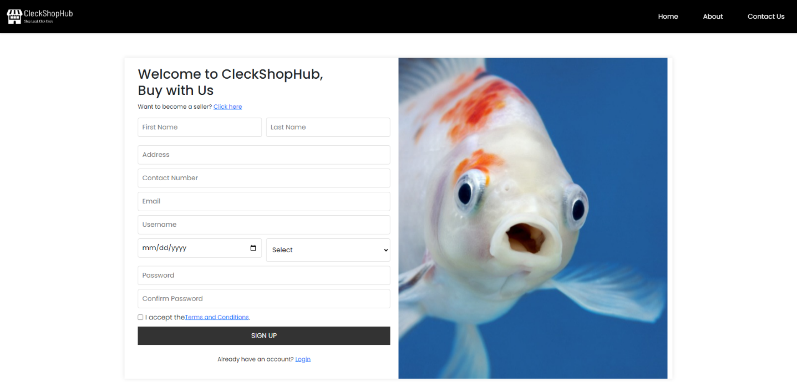

Figure 21: Customer Signup

### Customer Login Page:

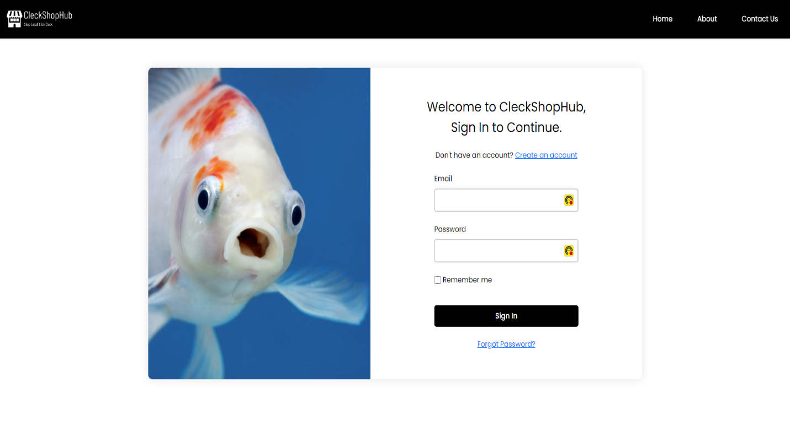

Figure 22: Customer Login

## Backend Development:

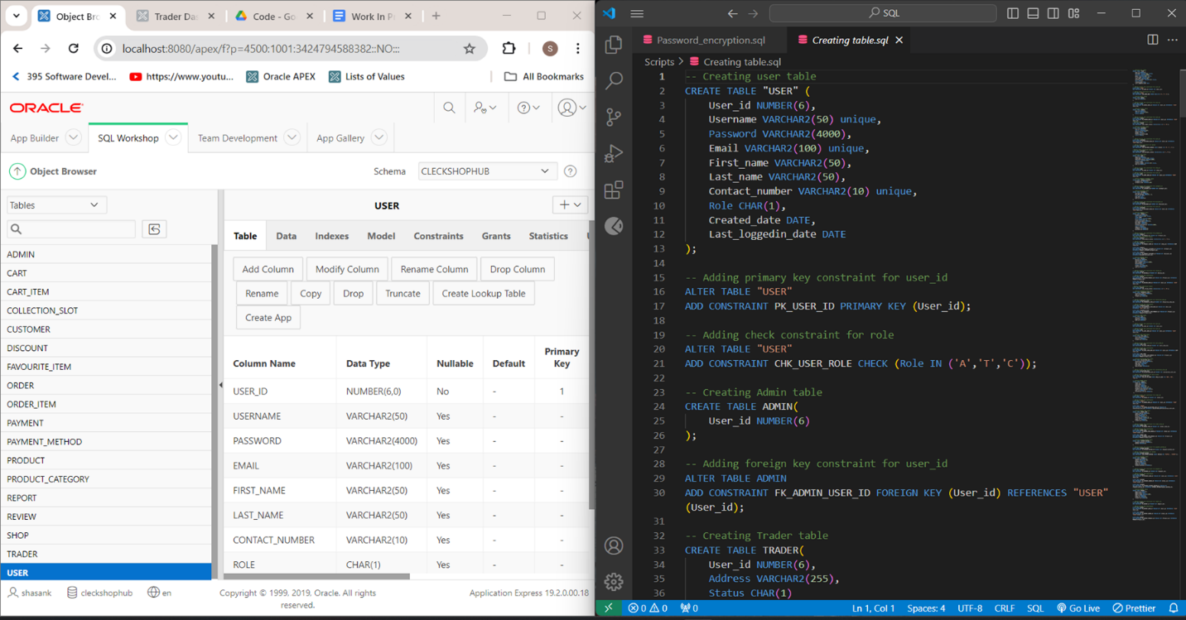

Figure 23: Tables Created

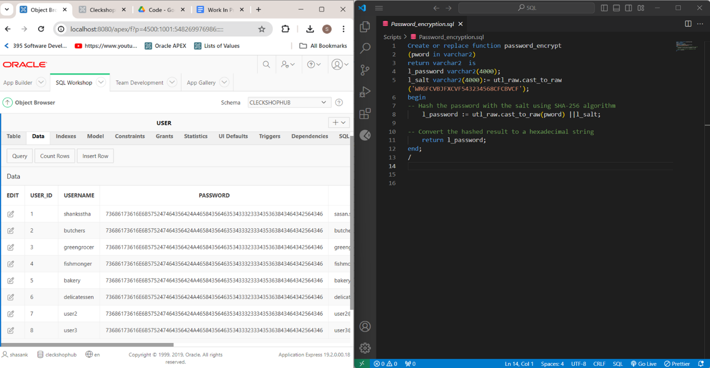

Figure 24: Password encryption

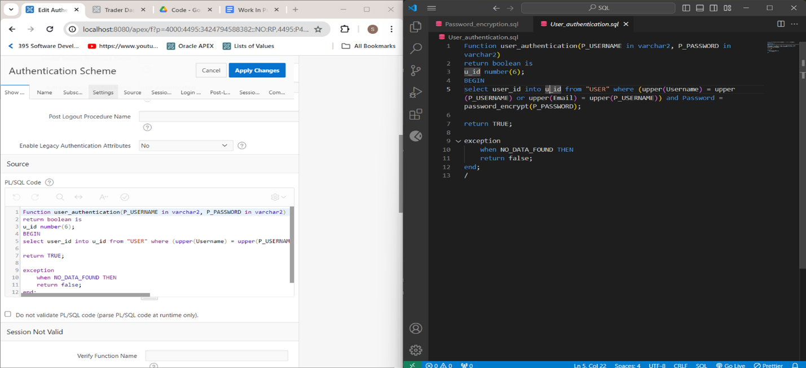

Figure 25: User Authentication

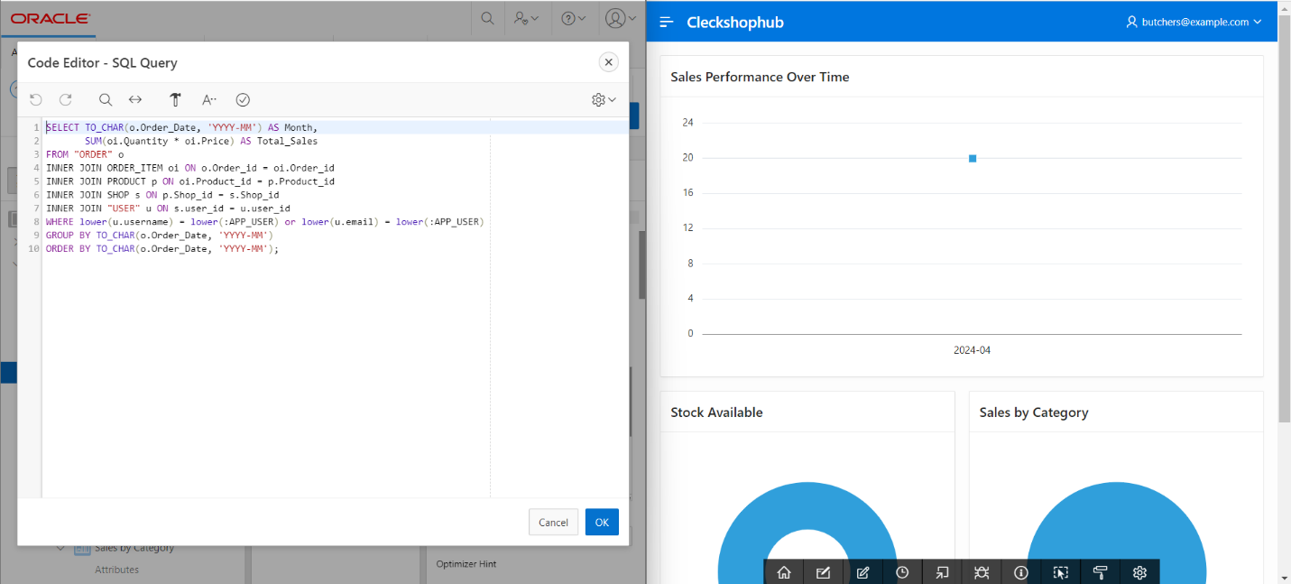

Figure 26: Trader Dashboard